FLUSH

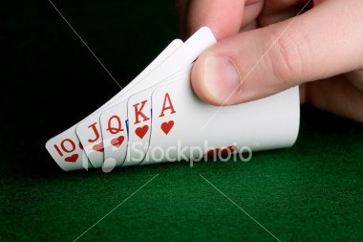
We all have the winning hand!!

This is not a trick

Enter at your own risk to learn about the greatest game on earth: the greatest deception since time began.
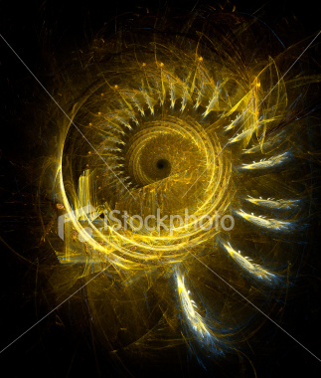
THOMAS F KITT

The winning secret:

There is no beginning to have an end

ALL IS LOVE

We are drenched in the recurrence of love and
it will wash us clean
if we allow it
.

This is the ultimate flush.


www.onepositive.com

