A PROCESS OF MOVEMENT

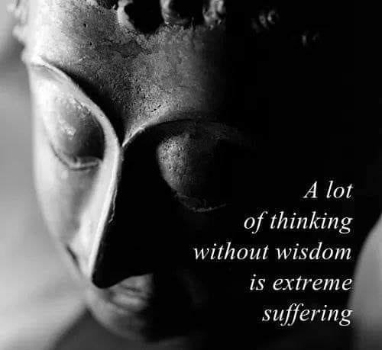

**“As careful attention shows, thought itself is an actual process of movement.”** – David Bohm.

Everything in the universe is replicating the same movement.

The movement is **thought** and all else is ‘thought’ thinking.

The primal movement is a twisted reality; an ILLUSION that feeds its issue with **proof**.

Offspring is generated by repetition, each thinking thing mini-Me’s looking to be fed.

And so, thought has its cake and eats it too as it paves its way with the bodies of its breed.

Make no mistake, this is exactly how it is and to look closer one sees the universe as a movie playing from a single movement that is the sum of its own thinking in every passing moment.

We are the monster that orchestrates the balance of life through war’s genocides or whatever it takes to maintain the platforms of ignorance we defend as real.

Thought is everywhere at once doing our will under cover of darkness.

Let the good times roll, I am not to blame.

**“Multiplicity is only apparent, in truth, there is only one mind...”** ~ Erwin Schrodinger.