**Chapter: Tribal Fear – The Illusion of Safety.**

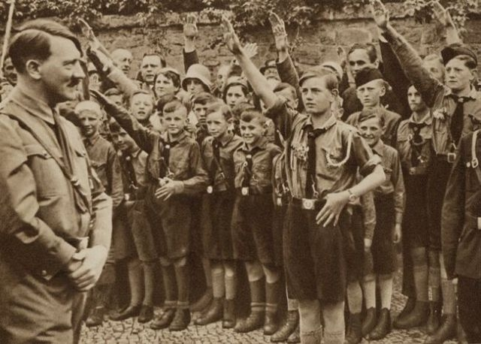

Every being arises from the rhythm of recurrence, yet the mind, terrified by the dance of impermanence, fabricates security by partitioning the indivisible.

The tribe, once a vessel of sharing, becomes a fortress. In our attempts to belong, we forget we’re already whole.

“There are no higher beings to guide the way, all are trying to be safe…” — TRIBAL FEAR

Fear is the centrifugal force pulling unity apart—masquerading as order through hierarchy, domination, and the mythical “master.” But the master is only ever the sum of fearful thoughts—a mosaic of survival dressed in charisma and certainty. Watts’ wild man—the Joker—knows this and plays the mirror, cracking our illusions with laughter. Yet, laughter is dangerous. Learning is treason. Why? Because revelation loosens the tribal knots, and what’s a tribe without shared defense?

So we punish the mirrors. We canonize the dead philosophers and exile the living ones. Even Watts gets sanctified, neutered, and misquoted in service of new power structures. Wisdom becomes costume. Authenticity, threat.

But unity was never about agreement. It is the memory encoded in every waveform—that the observer and the observed are made of the same oscillation. What appears different is simply the angle of return. As Aristotle echoes, “The whole is more than the sum of its parts.” The real danger isn’t in the difference—but in forgetting we are one rhythm expressing uniquely.

We are not becoming. We are remembering.