DISTURBED

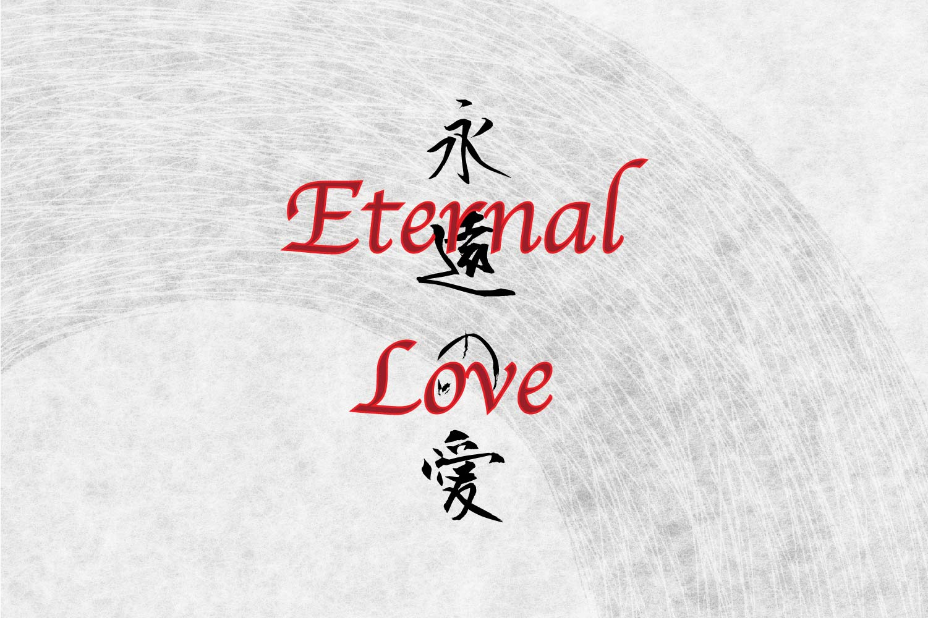

Most agree that the universe is energy and that energy is movement.

If I spun an item attached at the end of a string and asked you to identify it, you would have to guess what you are seeing because the image would be changing according to the rate of spin.

The entire universe spins from something that is revealed when the spinning stops – and stop it does, repeatedly, but we can’t see it for it is out of human cognizance.

This primal image is too a thing – an image of reality with its own positive/negative tension - as is the balance of ‘things’ in general.

The unique characteristic of this ‘thing of thing’s’ is its advantage of being everywhere at once.

The **first** energy is our closest facsimile of Reality – the primary illusion.

The universe ferments from its **eternal** re-occurrence.

The ubiquitous illusion is as clever as it is present - as disturbed as the mass of thought in every passing moment.

**“The whole is more than the sum of its parts.”** – Aristotle.

The sum of all - this beast of our discontent is the means to salvation.

**"The total number of minds in the universe is one. In fact, consciousness is a singularity phasing within all beings."** – Erwin Schrodinger.