ILLUSION IS REAL?

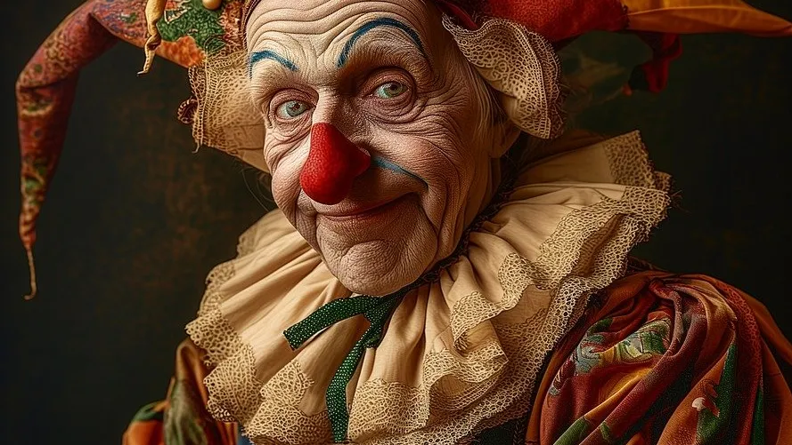

The most difficult thing is to boil everything down to its absolute simplicity and then have the grace to be embarrassed.

*

ALL AS ONE we had a thought.

Thought is a verb and so is movement - an energy - something provable and therefore worthy of consideration -

ALL IS ONE - never two!

Thought is illusion because anything that moves is not what it is when 'not moving'.

The universe is the secondary result of the same eternal movement - just as a hairdryer or any appliance except the universal generator is plugged into Eternity.

Free energy!

**"Draw from it as you will, it never runs dry."** - Tao Te Ching.

As Thought proceeds to think, it produces the means to defend its authority.

Thought is the algorithm that controls all algorithms because there is no algorithm that is not the movement of thought.

It cloaks us in complexity and self-importance in order to protect the illusion.

Proof fools us to follows illusion.

Disable your high-brow camouflage and realize that just because Illusions can be proven doesn't mean they are real.

Only a fool believes ILLUSION is real.