PERPETUAL MOTION MACHINE

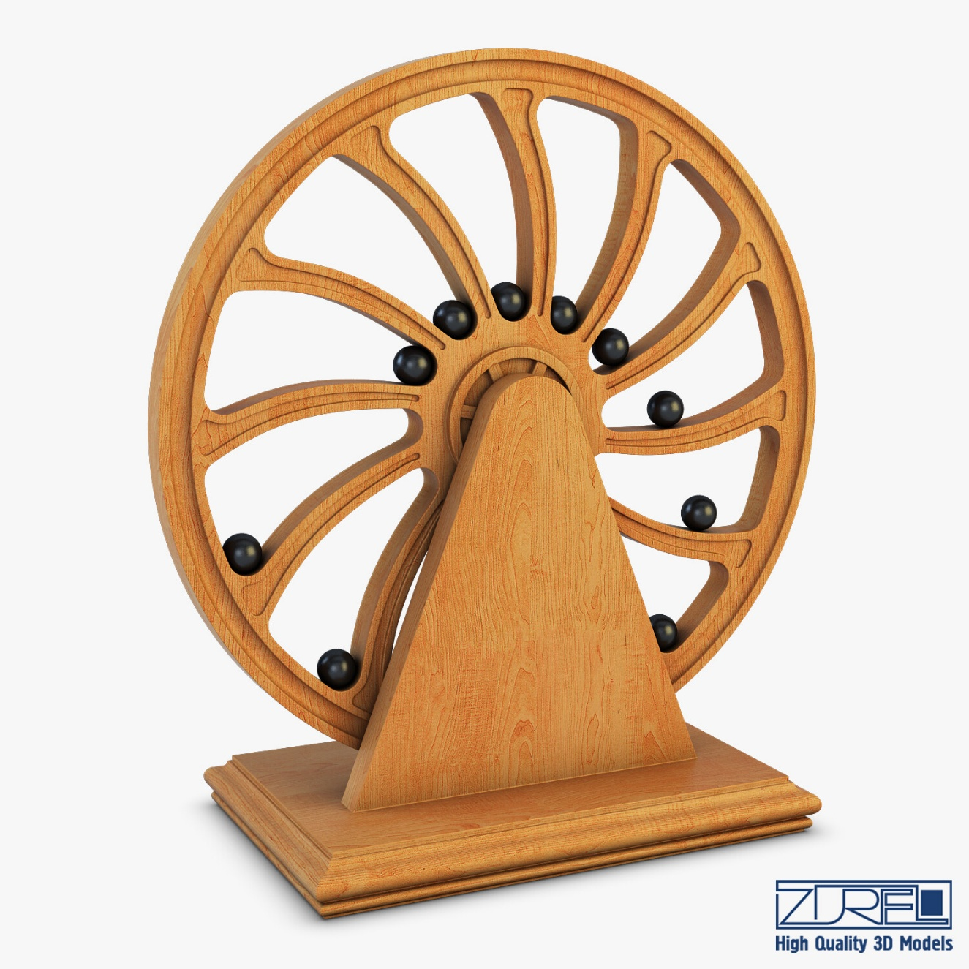

A perpetual motion machine turns out the same energy ad infinitum. It does this without cost or so it seems. When the design is perfected, we will have energy for free.

This hearkens back to Nikola Tesla.

One thing for certain: energy is a positive/negative exchange; a resistance to be resolved.

The 'free energy' machine replicates its own cause and in due course the build-up of free energy might resolve the resistance, but then, we'd have nowhere to go and nothing to do.