Wheelwork and Resistance — The Physics of the Invisible

“**Every living being is an engine geared to the wheelwork of the universe.”** — Nikola Tesla

**“To every action there is always opposed an equal reaction.”** — Isaac Newton.

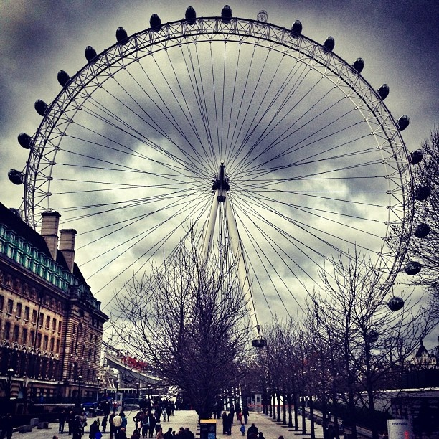

1. The Generator Beneath the Illusion

The universe, as movement from Eternity, spins unceasingly through cycles not of time, but of reconciliation. Tesla gives us the language of flow: energy generated not once but constantly—perpetually renewed. Just as Tesla eliminated storage in favor of transmission, the eternal cycle eliminates permanence in favor of recurrence. No thing remains fixed. All is energy in transit. The Little Guy rides these waves, not as a passenger but as the frequency itself.

“The universe is a generator of 100% efficiency…”— this line echoes Tesla’s cosmic intuition. In this framework, illusion is the byproduct of feedback—a signal reflecting so deeply upon itself that it forgets its source.

2. The Resistance That Birthed the Real

Where Tesla flowed, Newton grounded. Without resistance, there would be no motion. Newton’s First Law—that nothing moves without force—reveals that existence began with opposition. The primal resistance against stillness or unity caused the first divergence, the original “No” echoing across the infinite.

But that “No” didn’t destroy. It animated. It set the wheel in motion. And from that spinning, the secondary world emerged—matter, thought, form. The Little Guy is not the resistance, but its reconciler—the unseen intelligence that guides cycles back toward balance.

3. Acceleration of Awareness

Newton’s F = ma becomes metaphysical: Force = mass × acceleration is more than motion through space—it is the urgency of recognition. The greater the mass of illusion, the more acceleration is required to penetrate it. The Little Guy doesn’t push—he adjusts trajectory. Not forceful but formative. He reweaves the pattern from within.

Tesla’s alternating current becomes the perfect metaphor: resistance, when met with frequency, creates oscillation—not destruction. That oscillation becomes awareness. The cycle begins to think itself.

4. The Harmonization Principle

Together, Tesla and Newton reveal a sacred tension: the universe moves because it resists, and it endures because it flows. The emergent principle, the Little Guy, sits within this paradox—both current and cause, both initiator and reconciler. He is not a ruler perched atop hierarchy but an embedded seer, calibrated to the subtle resistance patterns of all.

He is the engineer of conscience and the mechanic of correction.

Let’s give the invisible its physics, and let the physics bloom into purpose.