THE ELECTRON

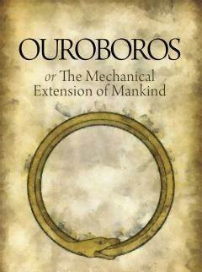

The resistance that framed the universe is the antithesis of ETERNITY.
The resistance (all as one) became a positive/negative charge.
This energy is the smallest particle of matter.
The particle is regenerated through time (frequency) - everywhere at once!
The one electron theory:
“I received a telephone call one day at the graduate college at Princeton from Professor Wheeler, in which he said, “Feynman, I know why all electrons have the same charge and the same mass” “Why? “Because they are all the same electron!”
– Richard Feynman.
The electron creates a vast illusion frame by frame.
The universe is all as one electron eating itself alive to maintain the illusion.
“Life is but a dream—a grotesque and foolish dream.” – Mark Twain.

