THE LITTLE GUY

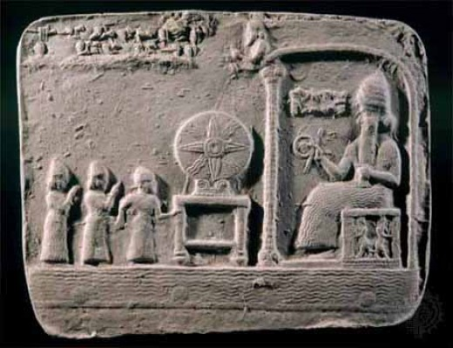

The universe is a movement from **Eternity** that repeats without cost until its issue is reconciled.

The cause of the movement turns the wheel that produces the universe; producing facsimiles of itself – bigger illusions that have little idea from whence they come and really care less as long as they are getting what they think they need.

The big guys and the little guy are all as one but with one huge difference: the little guy is everywhere at once because he is the smallest - all else descents hierarchically.

This allows the little guy the supreme advantage of seeing through all eyes at once without anyone else knowing he’s there.

He watches for those who threaten his dominion and can sent whatever is best for every situation.

He is the ubiquitous sum of his own thinking - the sum of our thinking, and no matter how we excel, no matter how we succeed as individuals the emergent principal maintains the upper hand.

And so, we are controlled by the sum of our own thinking – inseparable, except the little guy is higher than the sum of its parts.

**“The whole is more than the sum of its parts.”** – Aristotle.