THE POWER OF ENERGY

No one can naysay the universe is energy.

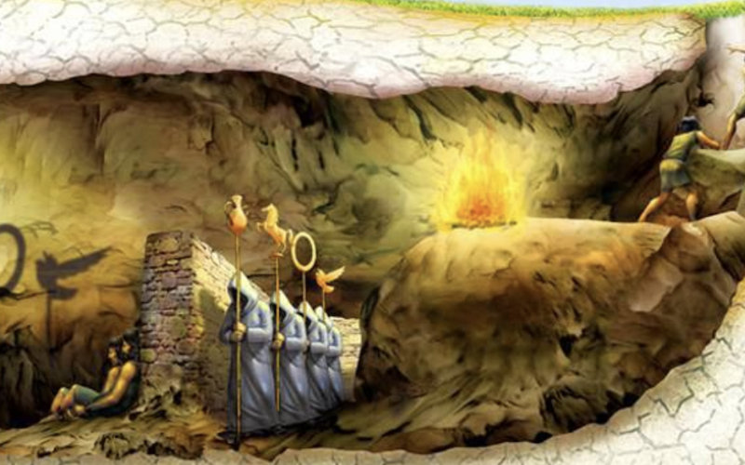

Energy is movement – movement is illusion.

We are ILLUSION.

**“Not to know it is blindness that works evil.”** – Tao Te Ching.

The illusion began when ‘all as one’ we resisted Eternity.

The universe is the secondary result of one eternally recurring movement. (primary generator)

The movement was caused by a thought, and the universe is the movement of this thought called thinking.

We are the movement of thought/ thinking – inseparable!

The secondary issue stamps the illusion as ‘real’ because each repeat is proven by the references that support it.

And so, we follow ‘proof’ because it suits our purpose to live as we will, believing we are real.

**“The whole is more than the sum of its parts.”** – Aristotle.

In any life, not to acknowledge the energy illusion is to submit to forces unknown.

Should the illusion reveal we are loath to change direction.

But change we must!

SYNOPSIS:

In the beginning: one movement caused by resistance. This resistance came from all as one.

The movement repeats as long as the resistance remains.

All as one we protect our growing issue - and very present we are in face of the fact that the energy illusion is the most common and obvious fact to be realized - yet we refuse to see.

All as one we have a stranglehold on our parts for life in illusion is tenuous at best.

**“Those who are able to see beyond the shadows and lies of their culture will never be understood, let alone believed, by the masses.”** – Plato.