THE THOUGHT PULSE

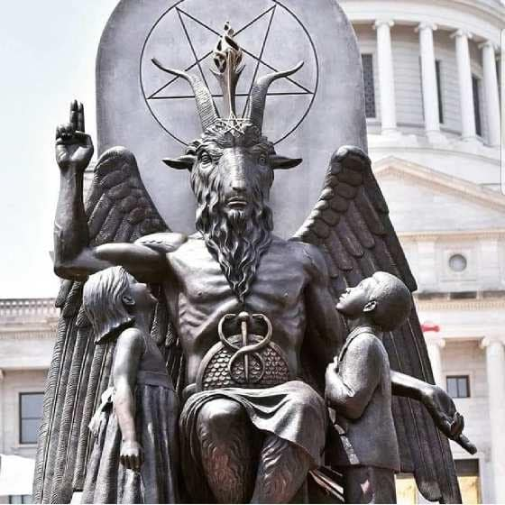

(**Ancient Greek δημιουργός (dēmiourgós), “one who works for the people; a skilled workman, a handicraftsman”).**

~

**“Multiplicity is only apparent, in truth, there is only one mind.”** ~ Erwin Schrodinger.

The heartbeat of the universe pulses from ETERNITY and because it is a movement the universe is ILLUSION.

Frequency is without limit because the pulse is ETERNAL.

The cause of the circuit/pulse is denial.

Denial comes from a thought/antithesis.

The pulsing of thought is thinking in action.

The universe is the mind of thought.

**“The whole is more than the sum of its parts."** - Aristotle.

There is little time for 'thought' and the aggregate of thinking from the annals of time is its constant moment.

Thought is everywhere at once; a daemon growing its kingdom and sending its minions to maintain its illusion in time.

We are part and parcel - inseparable!

**“As careful attention shows, thought itself is an actual process of movement.”** – David Bohm.

Thinking is resistance in action - parts generating parts, but the frequency of everything is the ever-present thought.

Tesla Insight—the resonance between scientific principles and metaphysical exploration is unmistakable.

The entire universe is a function of Ohm's law constantly resolving to thought.

**“I will ascend to the heavens; I will raise my throne above the stars of God; I will sit enthroned on the mount of assembly, on the utmost heights of Mount Zaphon. I will ascend above the tops of the clouds; I will make myself like the Most High.”** – Isaah 14:13-14.

The daemon **thought** sheds itself to live, it has no empathy or compassion as it directs all that it is with impunity.

Pain chases us until we wake up!