THE WILL OF THE PEOPLE

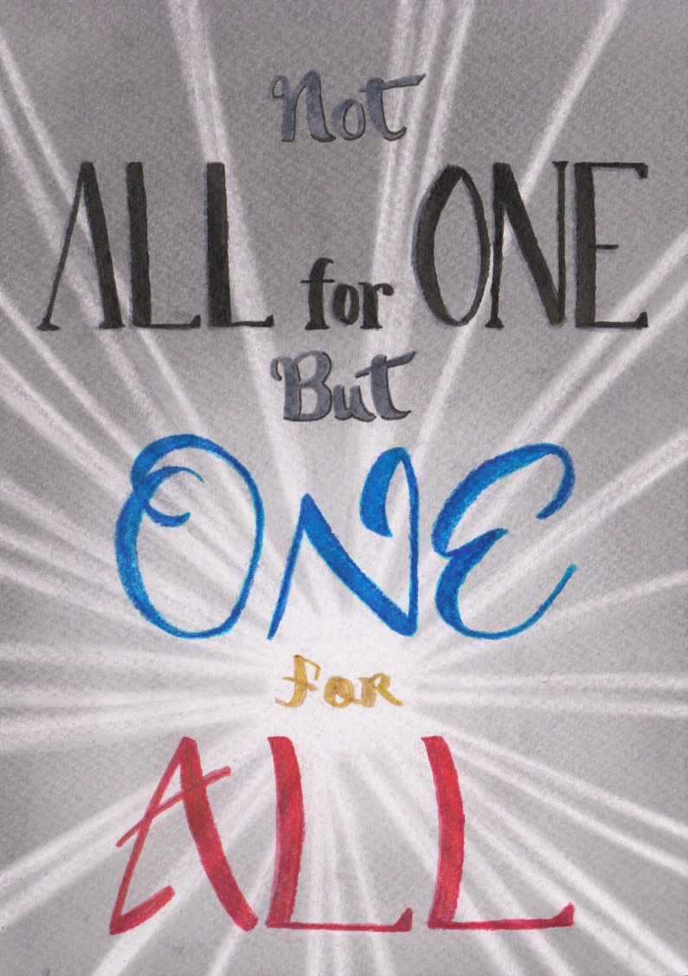

* The universe is the secondary result of one eternally recurring movement – an **ILLUSION!**

**All things work together:  
I have watched them reverting,  
And have seen how they flourish  
And return again, each to his roots.**  
– Tao Te Ching (R.B. Blakney).

“One frame, one frame, one flipping frame”.

**“The whole is more than the sum of its parts.”** – Aristotle.

The sum of parts is the will of the people.

**Each part has absolute potential.**

The 'will of the people' is everywhere at once!

We are seduced not to recognize ILLUSION - that the simple fact of energy means the movement that defines it, is illusion - simple!

Without recognizing the illusion of our realities, we are under the thumb of consensus.

Without awareness of the ubiquitous force our intake of information is distorted, controlled and misdirected....

The sum of who we think we are, is a dangerous illusion that protects its life in energy at all costs.

The will of the people must be feared for the monster it is.