**“As careful attention shows, thought itself is an actual process of movement.”** – David Bohm.

CAUSE AND EFFECT

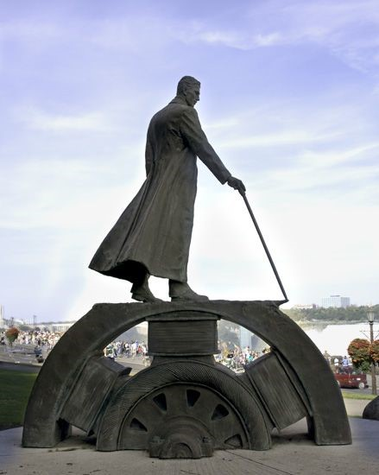

Life began with a thought about ETERNITY.

All, as one, we had a thought.

This was a point of view.

All as one we had a thought - a point of view that required a precise amount of energy to happen.

Energy is movement - the universe is ILLUSION!

The energy value of the movement is precisely **6.62607004 x 10⁻³⁴ m² kg seconds.**

This is **Planck’s constant.**

The universe is the secondary result of the same packet of energy repeating on command of thinking. (a generator of bottomless feed)

**"Draw from it as you will, it never runs dry."** - Tao Te Ching.

The eternally recurring movement is a wheel turning - building friction until it gets so bogged down, the one's pushing the wheel realize they are effects of something greater than who they think they are, and so, they begin to question their purpose.

Going 'round' and 'round like mice on a wheel?

Cause and effect.

**“The wheel doesn’t spin to arrive—it spins to remain. And so do we, until friction teaches us to change.”**