CREATURES OF A SEASON

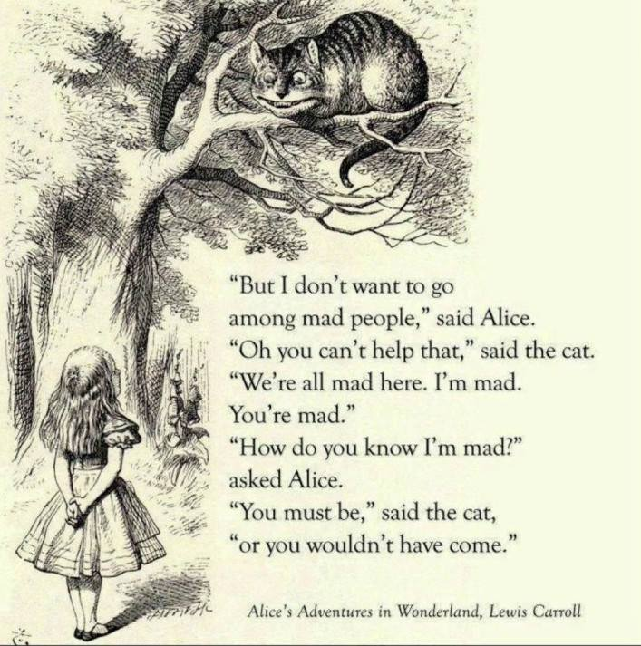

**“You cannot speak of ocean to a well-frog; the creature of a narrower sphere. You cannot speak Office to a summer insect; the creature of a season.”** – Chuang Tzu, 360BC.

In essence we are immortals who have sold our souls for a bag of rice that can only be as good as rice may be and therein our only comparison, for we know not the most basic workings of our state of being.

There is no attitude of servitude that commends the master more than the desire to be the master and so we plot.

Jealousy and desire to be the best, to see the challenge and know it can be overtaken – to be vigilant for the next contender.

Human beings are low creatures who don’t know they are illusions in spite of being energy.

We are low because in spite of energy we believe we are real.

We are low because we have no enquiry other than to feed our advantages.

No one knows what Isaac Newton meant by **F=ma** or Max Planck by **E=hv.**

Or, Nikola Tesla by **AC.**

We don’t even have a clue that AC is **eternal recurrence.**

We actually care less as long as we are getting our due and fulfilling the social agenda – fitting in.

You don’t know or care that the universe is a cycling event going nowhere.

That there is no universal education, only starting salaries.

No wisdom but to feed and greed with impunity.

Who even knows why **E=mc²** blew up the cities of Hiroshima and Nagasaki to exploit the ego of a small man with a big gun.

Trump and Musk – ignorant as Harry.

The Pope - dangerous nonsense, he should be questioned about basic energy principles.

Does anyone even know that because we are energy, all is ILLUSION?

Humans need to believe they are clever and sensitive, to be respected, but really, we can’t even answer the most basic questions about how the universe works.

Ask yourself “what is energy?”

**“It is important to realize that in physics today, we have no knowledge of what energy is**.” - Richard Feynman.

There is no point in talking physics to people who don’t comprehend what Tesla meant by.

**“Eternity is the source of energy.”** ~ Nikola Tesla.