ETERNAL SECRET

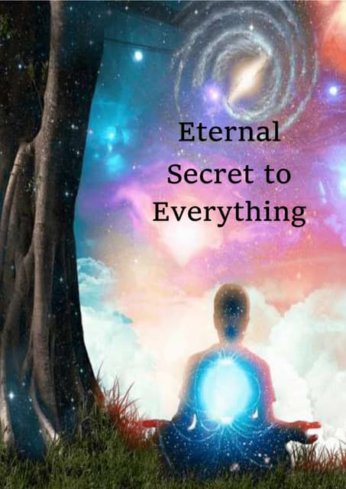

2 is more than 1 but whereas one has no other, two is an interaction - a system to be explored.

The entire universe is energy: a system to be explored.

No matter our energy conclusions 1 is ever-present - there is no 2 without 1.

1 is the completeness of 2.

This completeness is ETERNITY.

We come from Eternity in discreet packets of energy called quanta.

The universe is the secondary effect of quantum repetition and even though this has been understood for some time, few are available to it.

The sum of quanta becomes a natural force-field against 1.

**The whole is more than the sum of its parts."** - Aristotle.

The aggregate centers on an emergent principal that directs all as one.

It directs one against one.

1/one in energy is thus created by its aggregate to deny the presence of the one that is there already.

The challenge for humanity is to become one for real.

To be ETERNAL.