ETERNITY: ANATHEMA!

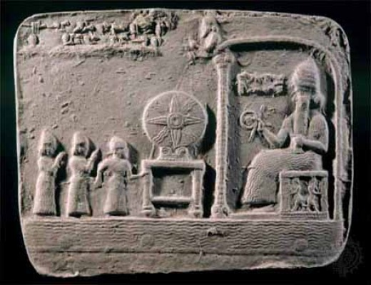



THE REASON WE DO NOT ASPIRE TO ETERNITY IS BECAUSE THE SUM OF 'WHO WE THINK WE ARE' WILL NOT ALLOW IT.

The world/universe is a mechanism – a generator such as a hairdryer, except, the wheel is Eternally recurring.

The expanding 8 billion outputs are kept unaware of their Eternal source by the resistance that caused it - **All as one**.

The sum of who we think we are, is the mind of humanity.

**"The whole is more than the sum of its parts."** - Aristotle.

The "whole' is everywhere at once influencing its offspring to believes they are real no matter it being obvious they are energy/movement - illusions!

The master of the wheel lives through its parts and a tenuous existence it is for should even one part realize they are following an illusion the whole system begins to topple.

ALL AS ONE WE DO NOT ABIDE THOSE WHO SEEK TO ESTABLISH ETERNITY AS THE SOURCE OF ENERGY.

**"Eternity is the source of energy."** - Nikola Tesla.