ETERNITY: ANATHEMA!

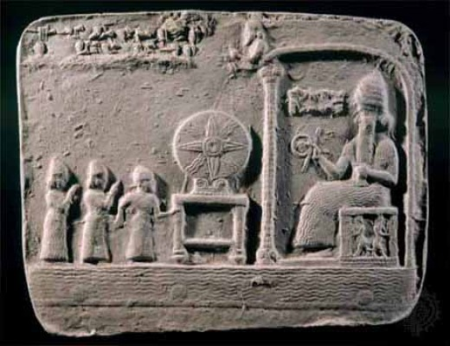



*The world/universe is a mechanism – a generator such as a hairdryer, except, the wheel is* ***Eternally recurring****.*

*The expanding 8 billion outputs are kept unaware of their Eternal source by the resistance that caused it - All as one.*

*All as one we are the cause of everything.*

*The cause is everywhere at once influencing its offspring to believes they are real no matter it being obvious they are energy/movement - illusions!*

*The master of the wheel lives through its off-spring and a tenuous existence it is for should even one come to know the illusion and act in truth there will be hell to pay.*

***ALL AS ONE*** *WE DO NOT ABIDE THOSE WHO SEEK TO ESTABLISH ETERNITY AS THE SOURCE OF ENERGY.*

***"Eternity is the source of energy."*** *- Nikola Tesla.*