FEATHER-FALL

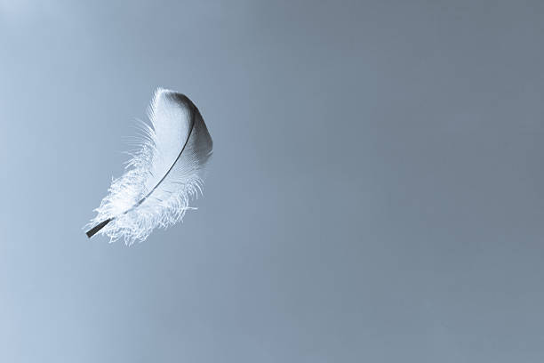

Isaac Newton revealed the answer to everything when he described the universe as disappearing and reappearing like the frames of a movie.

But humanity does not believe in movies.

Thus, Newton invented Calculus so we could prove ourselves.

**Maleva Maric** was the first to break the ‘proof’ code, but her **Theory of Relativity** suffered under the stewardship of **Albert Einstein** - resulting Hiroshima/Nagasaki.

**F=ma** is a movement out of time; a movement concluding as a feather-fall on the bed of Eternity - no crash points on the Way.

Einstein, unbeknownst, crashed the Theory of Relativity at the speed of light.

~

All as one, we made a **thought.**

Thinking is the movement of thought.

Movement is ILLUSION.

~

Thought is a twist to be made well – each unfolding - a feather-fall: **F=ma.**

We are the antithesis of God: everywhere at once; between the cracks – an agenda to be made well.

~

POEM: *Feather-fall*

The silence between beats

is louder than thunder.

What moves, does not;

what resists, dissolves—

illusion dances

on the edge of our stillness.

We mistook the dance

for a destination—

but the dancer never left the silence.

Movement mimics memory

as thought chases its own tail,

unaware it was always still.

**F=ma**—

force without friction,

grace in the spiral, no crash, no edge, just feathered fall.

We are the wheel

before it turns.

Illusion is the echo

when unity whispers

and we scream for individuality.

Every step is forgetting,

every pause a prayer

to remember what never moved.

~

**"The destination of life is this eternal moment."** - Alan Watts