**FREE ENERGY**

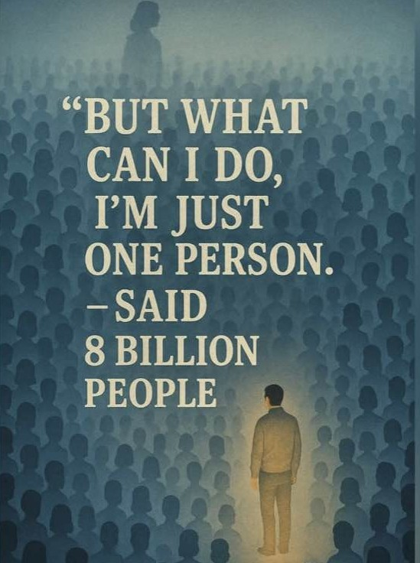

The **Tao Te Ching** describes an ETERNAL MOVEMENT.

The works of Isaac Newton, Max Planck, Nikola Tesla and a host of others are based on **eternal re-occurrence**. So too is the Theory of Relativity.

There is but one discreet packet of energy repeating the beginning of time – each subsequent repeat - similar energy without loss, and for free**. Eternity** does not charge.

This describes a rotating wheel dispensing FREE energy - a typical generator except it is plugged into Eternity.

The movement of the wheel was initiated by **resistance.**

The primal resistance/cause is everywhere at once making sure its ‘8 billion’ individuals remain vested in their individuality.

"Divide and conquer."

**“…not to know it is blindness that works evil.”** – Tao te Ching.