**"It's the chorus, not the soloist, that reveals the song of existence."**.

**F=ma**

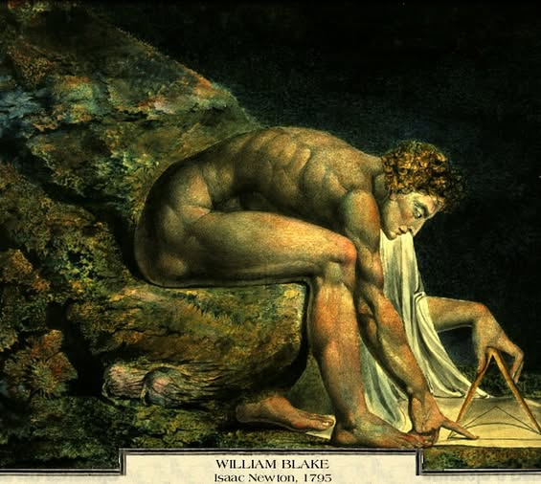

F=ma is a movement closing to Eternity.

~

The resistance that caused it is integral to the secondary output produced by eternal rotation.

~

All as one, we are everywhere at once - immanent!

~

All as one we use our parts to maintain the whole.

~

“THE WHOLE IS MORE THAN THE SUM OF ITS PARTS.” – Aristotle.

~

The 'whole' is the changing sum of who we think we are - a force of ignorance; everywhere at once, defending an IILLUSION.

~

**"The whole isn’t more than its parts—it’s distorted by what the parts believe they are."**