KNOW THYSELF

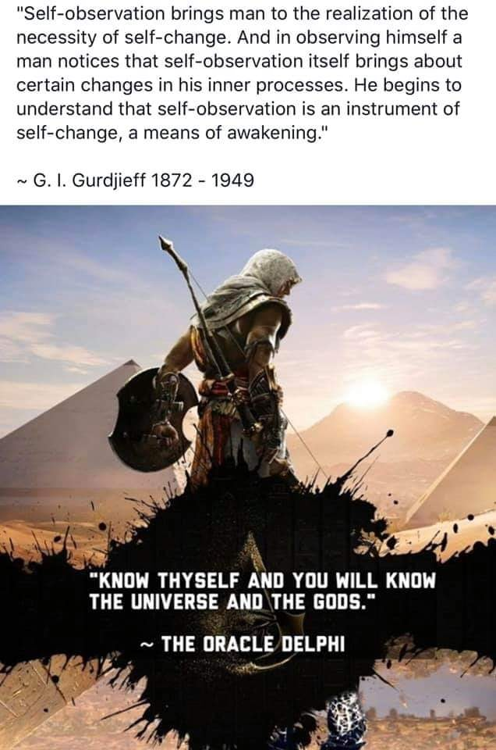

**“Man know thyself; then thou shalt know the Universe and God.”** - Pythagoras

The universe is by one eternal movement - one movement repeating from the beginning of time.

The illusion/movement/energy was caused by All as one which now exists as a being - everywhere at once because it precedes.

Insight:

**“I received a telephone call one day at the graduate college at Princeton from Professor Wheeler, in which he said, “Feynman, I know why all electrons have the same charge and the same mass” “Why?” “Because they are all the same electron!”** ~ Richard Feynman.

All as one we had a thought.

Thought is as a balloon we fill with thinking.

Thought and thinking are synonymous - inseparable!

One and the same except the mass naturally conforms to hierarchy under the control of thought.

**“The whole is more than the sum of its parts.’** – Aristotle.

The 'risen' sum/one is master of thinking.

**“No one has a right not to know who they are.”**