ONE WITH A TWIST

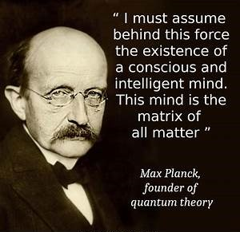

**“As careful attention shows, thought itself is an actual process of movement.”** – David Bohm.

The energy of life is the result of eternal recurrence…

One movement going on/off with impunity.

The cause of the movement is thought.

Thought is all as one – Eternity inside out.

This was a twist and not a break, for Eternity does not break.

The universe is a twisting movement attempting to right itself.

Thinking is the movement of thought – the twist repeating to meet the demands of its thinking.

The sum of thinking in any moment is the mind of thought in that moment.

**“The whole is more than the sum of its parts.”** – Aristotle.

Thought is resistance and as resistance grows, it gains the clout necessary to maintain life in time - life for its own sake.

Thought is the silent precursor, the originator of species.

We are the species of thought.

One and the same – with a twist.