SALVATION

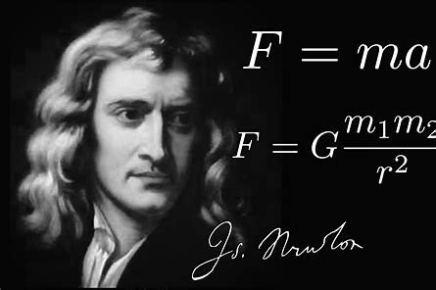

**F=ma** is the smallest particle disappearing out of time.

There are no particles in the universe per se, only movement.

The least movement is the smallest particle.

**F=ma** is a movement ending in nothing/Eternity.

All of science and physics is based on Newton’s work, yet **F=ma** has never been accepted.

Richard Feynman said:

**“It is important to realize that in physics today, we have no knowledge of what energy is.”**

Newton’s accelerating **mass** is energy.

To examine energy, it is necessary to consider where the movement came from and its cause?

The universe is produced from repetition of the Newton movement – such as the mechanic of a common generator - a cyclic to linear arrangement.

And, because the cycle is going out of time it may be said that the universe is the secondary result of the movements repetition.

This is ETERNAL RECURRENCE.

The cause of the movement was a disagreement cast out to be made well in energy.

This we achieve by our devices for we are cause and effect seeking the Love we are and ever shall be.

Life is Love denied.

**Eternity** is unconditional love - it does not move by any device.

All as one, we live in the illusions of movement but so far, we have not figured out that the sum of who we think we are is naturally ALL as one.

**“The whole is more than the sum of its parts.’** – Aristotle.

We are instruments of physical force marching for the one over-all.

We jump when the master calls, we destroy that which threatens life in energy.

We are lost outside ourselves, unaware that the collective dynamic is our means of salvation.

**One is all.**

**“The mind is its own place, and in itself can make a heaven of hell, a hell of heaven.”** ― John Milton, Paradise Lost.