**STOPPED AT THE LIGHT**

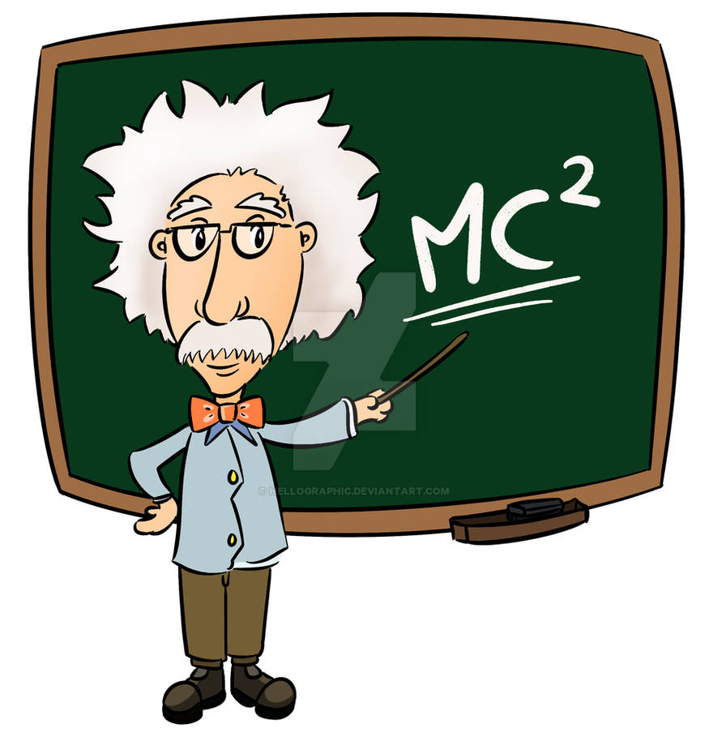

STOPPED AT THE LIGHT

The universe is from an eternal wheel spinning to produce output such as knitting needles producing fabric.

The resultant matrix is disappearing at each turn of the wheel/each stitch in time.

The cause of the wheel is the one who knits – this precursor is the resistance that initiated the wheel. Its greatest fear is for its creations to become aware of its presence for then it is subject to question.

The one on high remains in control because in spite of world knowledge there remains no acceptance that the universe is an eternally recurring event.

The 'collective' rules the roost.

Is it Einstein not astonishing how the **Theory of Relativity** was arrested at the speed of light by **Albert Einstein** (yet to be understood), the immediate cost, Hiroshima and Nagasaki nor that **Max Planck’s** quantum packet was changed from a movement out of time to a cycle in time. And is it not curious that **Nikola Tesla’s** AC works precisely because it is in tune with the disappearing universe.

8 Billions, all unique minds and there is no agreement on what is blatantly obvious - that which is happening in any case!

Such is the influence of the 'collective' one that few are aware it even exists!

Our Institutions of Education need to be challenged but by whom?

**“It is important to realize that in physics today, we have no knowledge of what energy is.”** - Richard Feynman.