TAKING STOCK

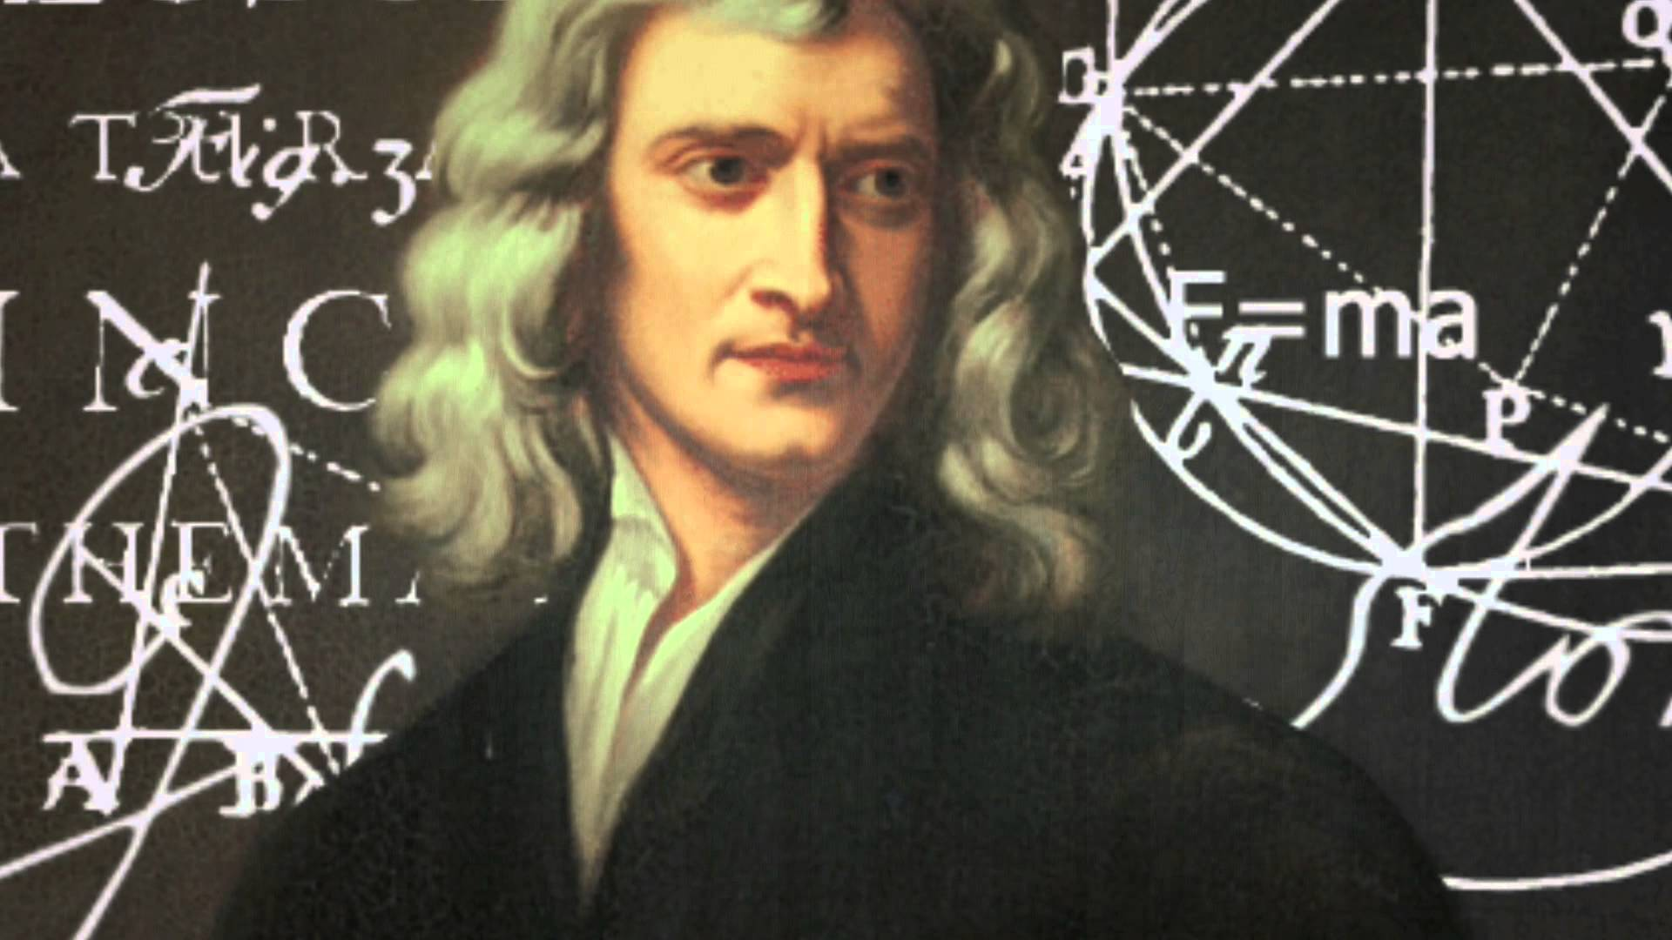

Isaac Newton gained inspiration from the Tao Te Ching and realized **F=ma** but such conclusive comprehension required a framework and so he invented Calculus.

**F=ma** was formalized by Maleva Maric and published in 1905 by Albert Einstein who did not acknowledge **F=ma** as the infinite conclusion of the universe. Instead, Einstein cancelled the movement at the speed of light and the world has been paying the price ever since.

**E=mc²** is a crash-point on the way.

The **Theory of Relativity** goes the infinite distance.

**“Einstein’s theories are nothing more than magnified mathematical garb which fascinates, dazzles and makes people blind…”** - Nikola Tesla.

The universe is disappearing and re-appearing at the speed of gravity and for science to move forward it must reset its enquiry from a position of having already happened.

The entire universe is an illusion of movement perpetrating itself like a movie playing.

But, the question of all questions is:

“Who is directing the movie?”

Humanity must reset its information before it can comprehend the radical simplicity of the Tao Te Ching as expressed by Isaac Newton.

**“Truth is ever to be found in simplicity, and not in the multiplicity and confusion of things.”** – Isaac Newton.