THE COLLECTIVE SHADOW

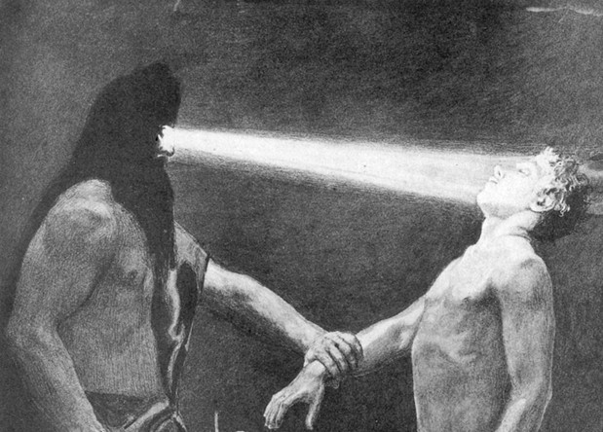

The world is energy, energy is movement - all is **illusion.**

There can be no disagreement about this unless you have something better to offer.

The movement began when **All as one** we denied **One is all.**

The former is a point of view, the latter the view.

**One is all** is ETERNITY.

We attempt to validate our ‘point of view’ with structure.

The primal movement has an energy value 6.62607004 x 10⁻³⁴ m² kg seconds.

This is **Planck’s constant.**

Planck’s constant is the **quantum**, and the universe is the secondary result of quantum repetition.

The archetype is revealed in everything that moves – take apart a kitchen appliance or a hairdryer and there will be found a wheel spinning output for the work to be done.

The sum of outputs is the mind of All as one.

**“The whole is more than the sum of its parts.”** – Aristotle.

All as **one,** we fortify the illusion with an army to command.

All as one we are as the ocean to a wave, those individuals who attempt to explain the truth are overwhelmed in due course.

Enquiry is but candy for children until we wake up to the fact that energy is illusion and we are fooling ourselves to stay alive.

We are all parts of the ‘whole’.

**“No one exists outside humanities collective shadow.”** - Carl Jung.