**“It is important to realize that in physics today, we have no knowledge of what energy is.”** - Richard Feynman.

THE EMOTIONAL ELECTRON

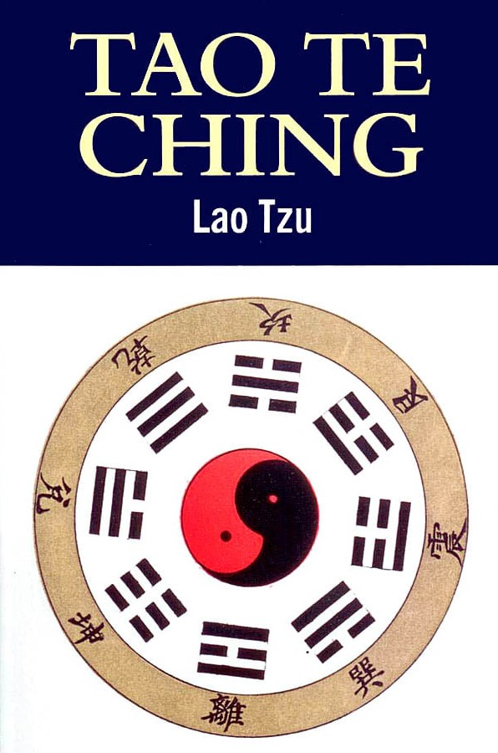

The will of the people is the sum of its own thinking - all as one.

An emergent principal enacts the collective will.

**“The whole is more than the sum of its parts.”** – Aristotle.

We are obliged to solve ourselves together – all as one.

The universe began when Eternity was resisted.

This was a twist and not a break – a movement!

Thus, the first positive/negative came to life.

As the duality rotates, the universe expands.

This is how generators work.

Whereas any appliance will achieve the work for which it is designed the universal generator provides energy for the universe at large – unlimited frequency – one twist at a time.

**“Draw from it as you will, it never runs dry.”** – Tao Te Ching.

Free energy – Nikola Tesla's mantra.

~The pos./neg. energy quantum is everywhere at once.

**“I received a telephone call one day at the graduate college at Princeton from Professor Wheeler, in which he said, “Feynman, I know why all electrons have the same charge and the same mass” “Why?” “Because they are all the same electron!”** ~ Richard Feynman.

To gain a foothold in reality one must be aware that because the emotional electron is everywhere at once its influence is as the ocean to a wave.

**“None of us stands outside humanities collective shadow.”** - Carl Jung.

Those that upset the ‘apple cart’ are attacked and minimized like white cells to a wound.

Understanding how the will of the collective is formed obliges one to personal responsibility to the truth of energy – the truth of what is happening anyway.

ETERNAL RECURRENCE is happening anyway.

**“No one has a right not to know who they are.”**