Thought/Thinking – SAME

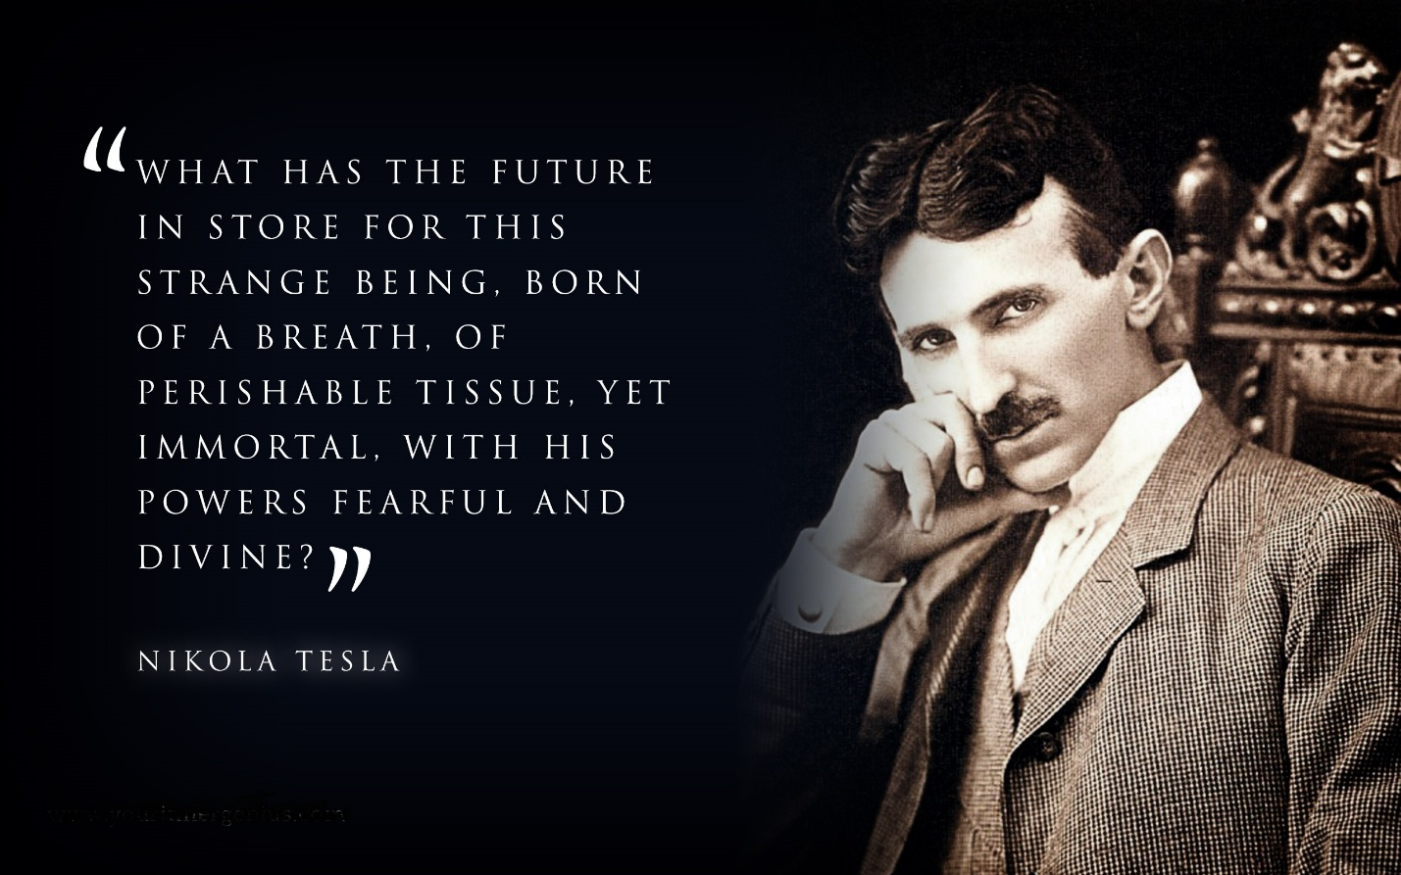

**Isaac Newton** gave us the all-inclusive F=ma and then invented Calculus.

He gave us the answer and then the means to prove it.

**“Truth is ever to be found in the simplicity, and not in the multiplicity and confusion of things.”** – Isaac Newton.

**F=ma** is a movement disappearing to nothing/Eternity.

The Eternally recurring movement breathes in/out and is the prototype of all secondary archetypes. (a generator such as any except it draws from Eternity.

**“Draw from it as you will, it never runs dry.”** – Tao Te Ching.

The cause of the movement is everywhere at once.

**“There is no thinker apart from thought; thought has made the thinker.”** – Krishnamurthi.

Understanding Mass (m):

Mass (m) is thought. (all as one)

Thought is the movement created by the first ‘point of view’.

Movement is distance between two points.

The smallest 'particle' is the least distance between two points.

The force (F) of the distance F closing is **ma.**

The force of thought is **F = ma.**

All, as one, we caused energy to happen.

Energy accumulates in discreet packets.

**“The whole is more than the sum of its parts.”** – Aristotle.

The universe is fermentation of one seed.

Thought is the antithesis of God/Eternity.