**WATCHED!**

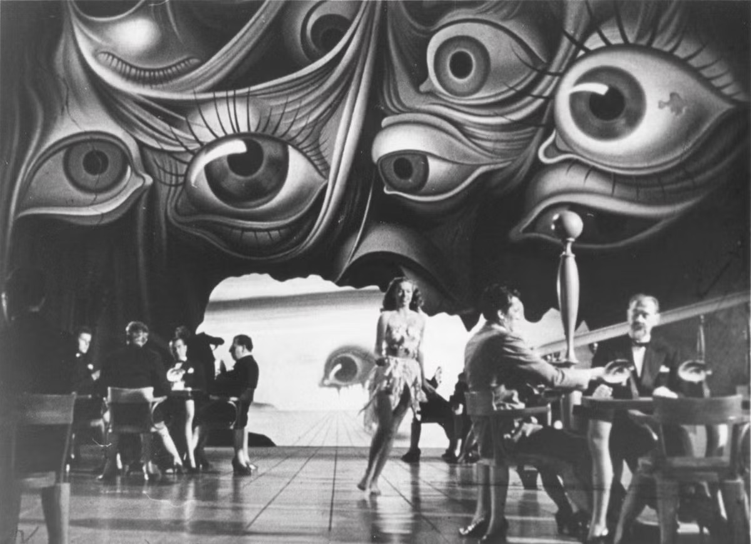

Isaac Newton explained the Tao Te Ching by using the equation F=ma but humanity requires concrete proof and so Newton invented Calculus; a system of calculation that meets every need until it reaches a point when required to make a leap of faith and acknowledge Eternity as the constant conclusion of everything.

F=ma goes the distance to infinity.

This is the Theory of Relativity.

Max Planck identified the eternal movement as a discreet packet of energy and named it Quantum. (6.62607004 x 10⁻³⁴ m² kg seconds.)

Nikola Tesla utilized eternal re-occurrence to revolutionize the world with AC current.

The resistance that initiated F=ma is constant throughout – everywhere at once.

It is only when one realizes that everything is watched by the primal being that one can even begin to release from its stranglehold.

The universe is generated such as output from a hairdryer.

The one in control is the constantly changing sum of who we think we are. (All as one)

All as one, is cause before effect, everywhere at once – up front and armed against those who challenge its control.

The universe is energy, energy is movement and movement is ILLUSION.

The illusion of life is blatantly obvious. Yet, the level of control is such that few are capable of admitting they are not real.

And those so few, made to suffer until they fit in.

We are fooled by the sum of our own thinking.

Nothing changes until we do.

~

*We are sophisticated  
We have information & knowledge  
We can conquer space  
Soon, we may bend time to our advantage  
Of course we are real!  
I can pinch my skin & feel the pain  
I can use my mind to create a dream  
I can procreate.  
I am man becoming God  
It is my birthright  
My reason for being  
My solemn promise  
I am man becoming God  
It is my destiny to bring the human experience  
To its ultimate potential – to realize itself****I am God becoming man.***