COGNITIVE DISSONANCE

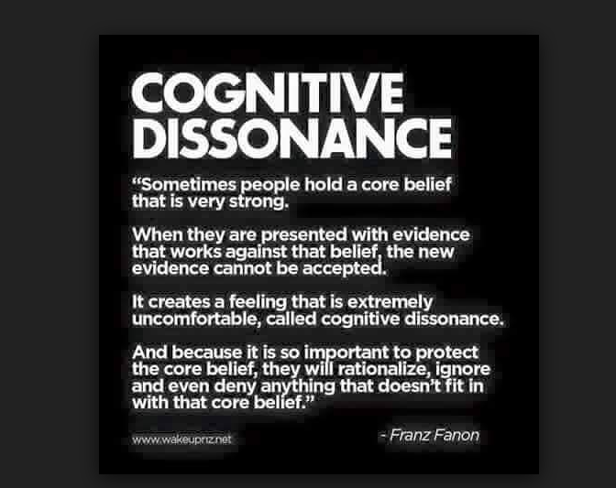

**“God is best defined as the first manifestation of Infinite Existence, the limitation of Limitlessness.”** ~ Manly P. Hall

One twisted movement is all and telling you that you that your thinking is the movement of a twisted thought is something you do not wish to know.

The mind of the eternal twist is the sum of its parts gathered as one.

**“The whole is more than the sum of its parts.”** – Aristotle.

Ignorance is a potent catalyst for survival and the sum of all is formidable...

It is the third party in every interaction and protects the life of energy with a power unknown.

It cleverly assimilates attempts at transcending the morass and to this day we are in such a state of cognitive dissonance we can’t even establish that energy is illusion.

As long as we believe we are real we have no foothold in reality.

We do this to ourselves!

**“I would say that in my scientific and philosophical work, my main concern has been with understanding the nature of reality in general and of consciousness in particular as a coherent whole, which is never static or complete but which is an unending process of movement and unfoldment…“** ~ David Bohm, book Wholeness and the Implicate Order.