COMMON SENSE

**“Common sense is not so common.”** – Voltaire.

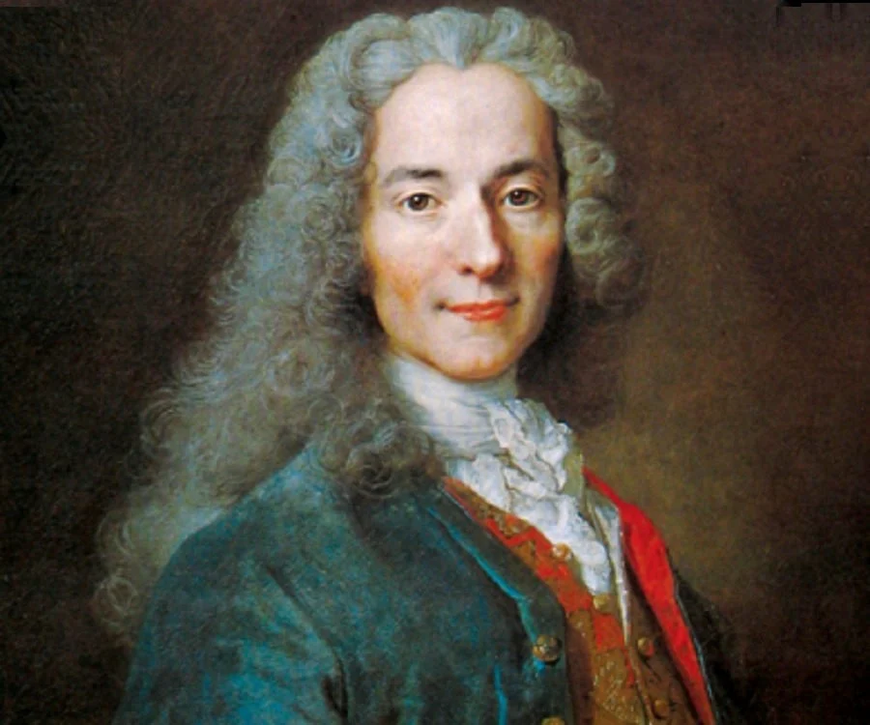

The biggest problem with humanity is the lack of common sense:

THE UNIVERSE IS ENERGY – ENERGY IS MOVEMENT – MOVEMENT IS **ILLUSION.**

Why will we not agree that we are illusions when it is irrefutable?

**"The first principle is that you must not fool yourself and you are the easiest person to fool."** - Richard Feynman.

**“Eternity is the source of energy.”** – Nikola Tesla.

**Isaac Newton** (F=ma) told us that energy is the same movement disappearing at the speed of gravity.

**Max Planck** described the movement as the Quantum.

Yet, the human experience wants to maintain its chosen path.

The common sense of recognizing energy as illusion will set our course differently.

Ask anyone if they believe energy is illusion and the general reply might be ‘It’s real enough.”

Why do we lack the common sense to choose our path instead of it being chosen for us?

Energy has a hidden feature.

**“It is important to realize that in physics today, we have no knowledge of what energy is.”** - Richard Feynman.