ENTANGLEMENT

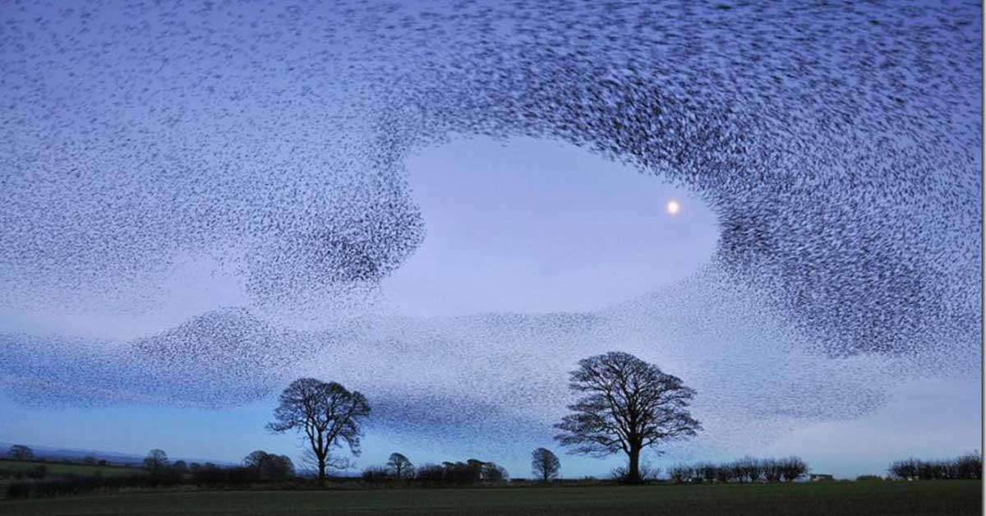

Behind the murmuration's of existence there is implicate order.

"The whole is more than the sum of its parts." - Aristotle.

The 'parts' are the eternally recurring bursts of energy described most especially by Max Planck.

The universe is energy, we all agree. Yet few will admit they are illusions.

Illusion requires 2 to happen; a positive and a negative.

The 'burst of energy' or the quantity of energy known as Quantum has reference and thus provable.

And, because energy can be used to protect us with all its wily ways, we gladly support and defend illusion as real.

There is no sense in this! For we know, deep down, energy isn't real.

We sell out and this is why we fear.

Eternity is real and energy is movement away from reality.

As long as we are complicit, we are part and parcel of an evil that is the risen sum of who we think we are. (evil backwards is 'live')

**“I will ascend to the heavens; I will raise my throne above the stars of God; I will sit enthroned on the mount of assembly, on the utmost heights of Mount Zaphon. I will ascend above the tops of the clouds; I will make myself like the Most High.”** – Isaah 14:13-14.

Common sense must precede, otherwise the one on-high - the sum of who we think we are, has us entangled.

We get entangled by our own thinking. and are obliged to figure ourselves out.

There is divine purpose in this.

ONE is all.

**“Ultimately, the entire universe...has to be understood as a single undivided whole.”** – David Bohm.