**“The task is... not so much to see what no one has yet seen; but to think what nobody has yet thought, about that which everybody sees.”** ~ Erwin Schrodinger.

FOR INSTANCE!

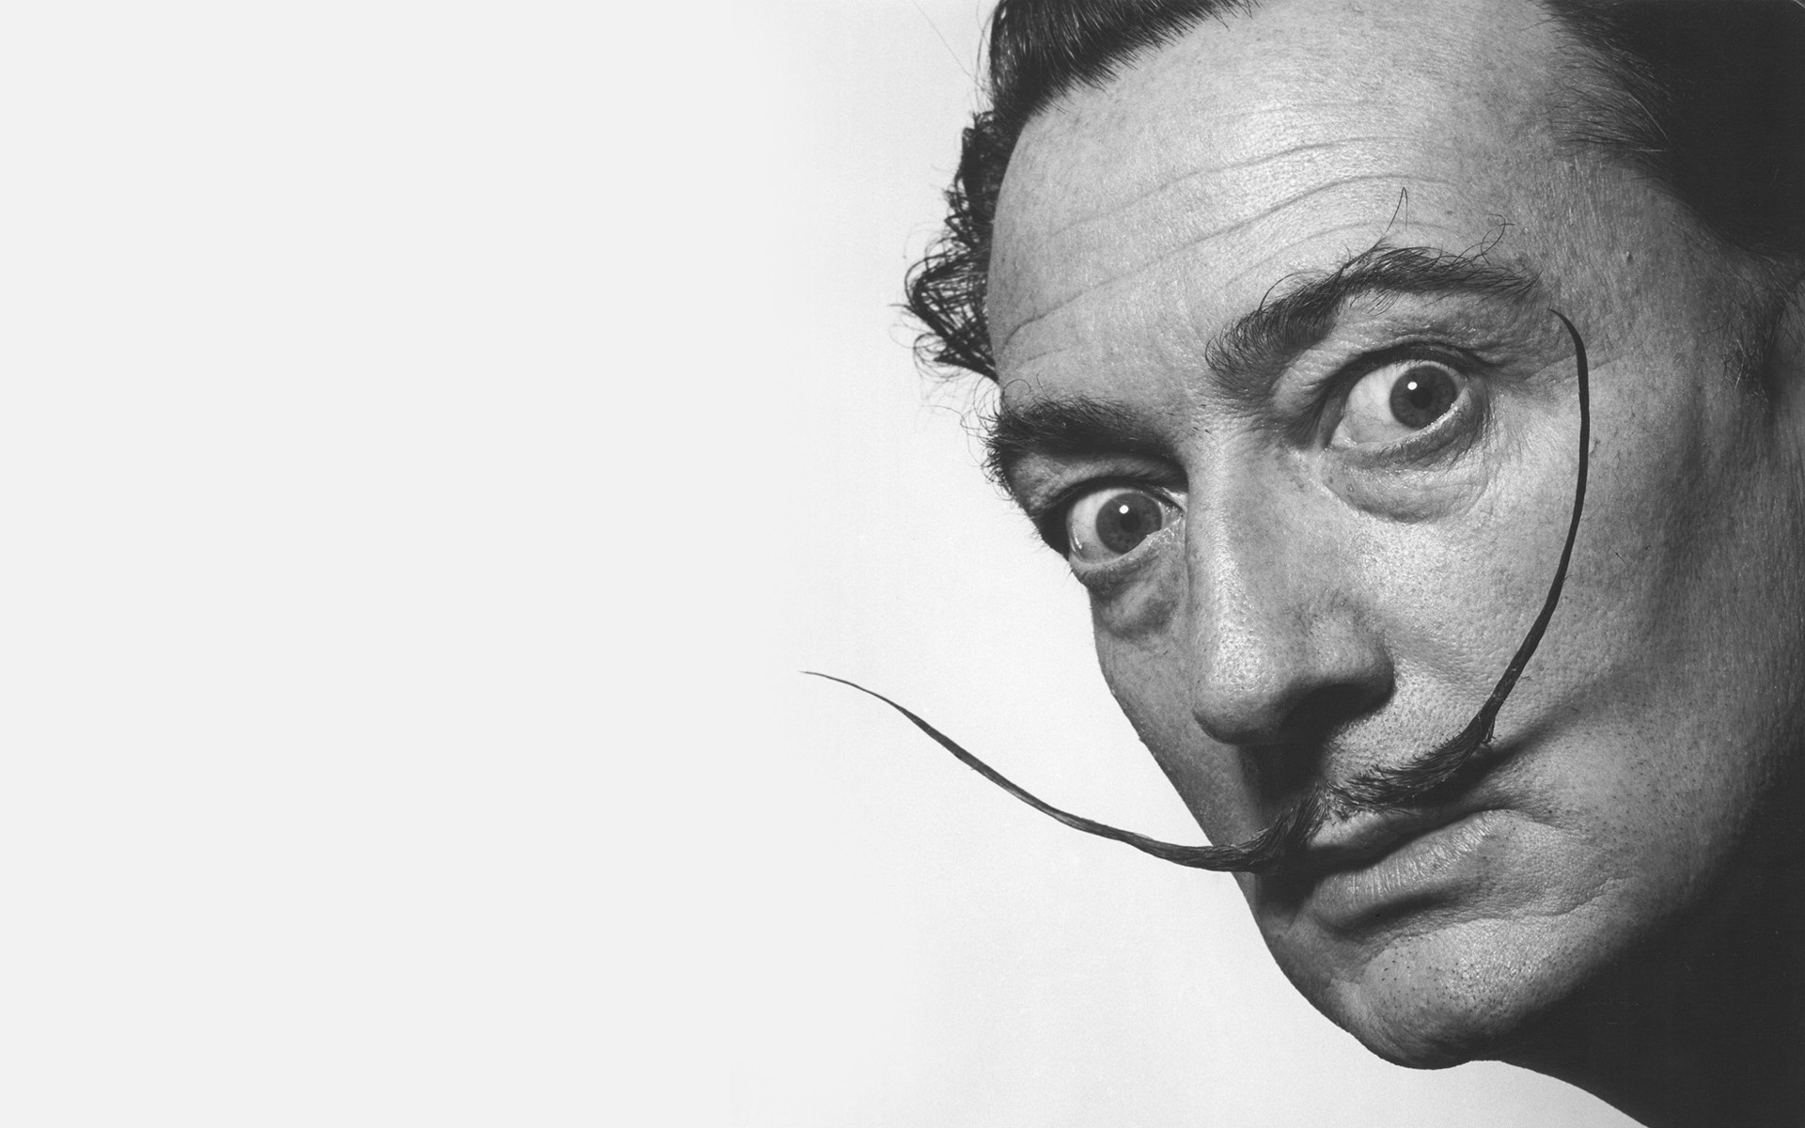

It all began from a silent resistance - silent only to our reckoning for it precedes us.

This resistance is thought.

The resistance came from Eternity and returns in the least time.

This is presented by a mobius strip cycling through its center but going nowhere.

The twist loops back and forth until the resistance is satisfied.

We build resistance to solve resistance but lose our way because the silent precursor is everywhere at once.

All as one, we turned One is all inside out for an instant.

We accumulate instants so we may complete any one of them.

This is the work to be done.

**"After knowing Eckhart Tolle for a while and studying the books, I woke up and suddenly got it. I understood suddenly how thought is just illusory, and that thought is responsible for most, if not all of the suffering we experience. And then I suddenly felt like I was looking at thoughts from another perspective, and I wondered, who is it that is aware that 'I' am thinking? And suddenly I was thrown into this expansive amazing feeling of freedom - from myself, from my problems. I saw that I am bigger than what I do, bigger than my body. I am everything and everyone. I am no longer a fragment of the universe. I am the universe."** - Jim Carrey