**"To see things in its seed, that is genius."** - Lao Tzu.

**FRICTION**

Energy/friction has a structured outlook.

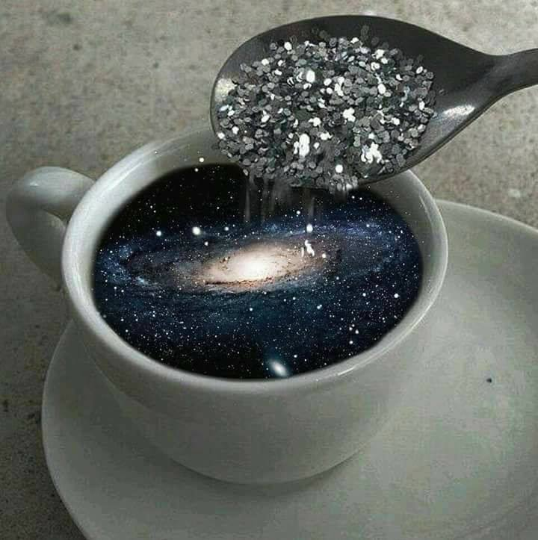

The universe is the secondary result of one eternally recurring movement.

The movement was caused by resistance/friction.

The universe results from an eternal wheel producing output: a generator pulsing energy for free.

**“Eternity is the source of energy.”** ~ Nikola Tesla.

Frequency causes the resistance to be everywhere at once.

Everywhere at once within structured outlooks that are gathering back to eternity with each turn of the wheel.

The entire universe is disappearing with each turn of the wheel.

~

The universe is maintained in time by frictional realities that insist they are real because they don't know who they are.

Ignorance is maintained by consensus.

**“The wheel doesn’t spin to arrive—it spins to remain. And so do we, until friction teaches us to change.”**

The wheel is disappearing to Eternity at each turn.

We too want to be safe, but energy/friction is never safe.

Friction produces friction and the changing forms continue until we wake up to what's happening whether we agree or not.

ETERNAL RECURRENCE is ongoing, and we must enter its flow to release from energy's hold.

**“It is important to realize that in physics today, we have no knowledge of what energy is.”** - Richard Feynman.

.

.

.

"We are stardust

Billion year old carbon

We are golden

Caught in the devil's bargain

And we've got to get ourselves

back to the garden." - **Jonie Mitchell.**