**"Please allow me to introduce myself..."**

**IL SINESTRO**

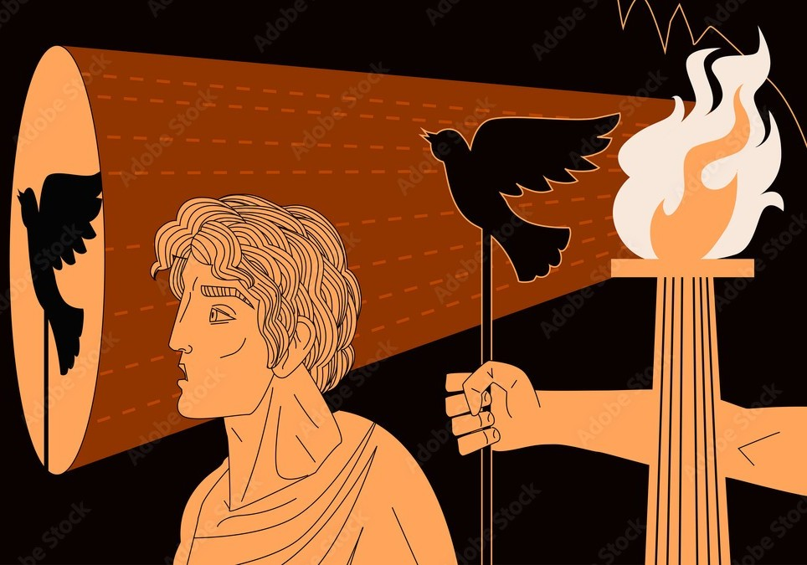

**"The whole is more than the sum of its parts."** - Aristotle.

The **emergent principal** is all as one: a creation that naturally ascends to the top of the energy hierarchy because, stranger than strange, this is its constant beginning.

All as one, we denied who we are and now we assert ourselves in energy by creating images.

Every image adds to the whole and the whole is reflected in the state of the world.

We are all as one being projecting images and living within them with impunity.

We play our parts, as the emergent principal plays all.

We have loosed a demon to serve us.

**“No one exists outside humanities collective shadow.”** - Carl Jung.