MOBIUS

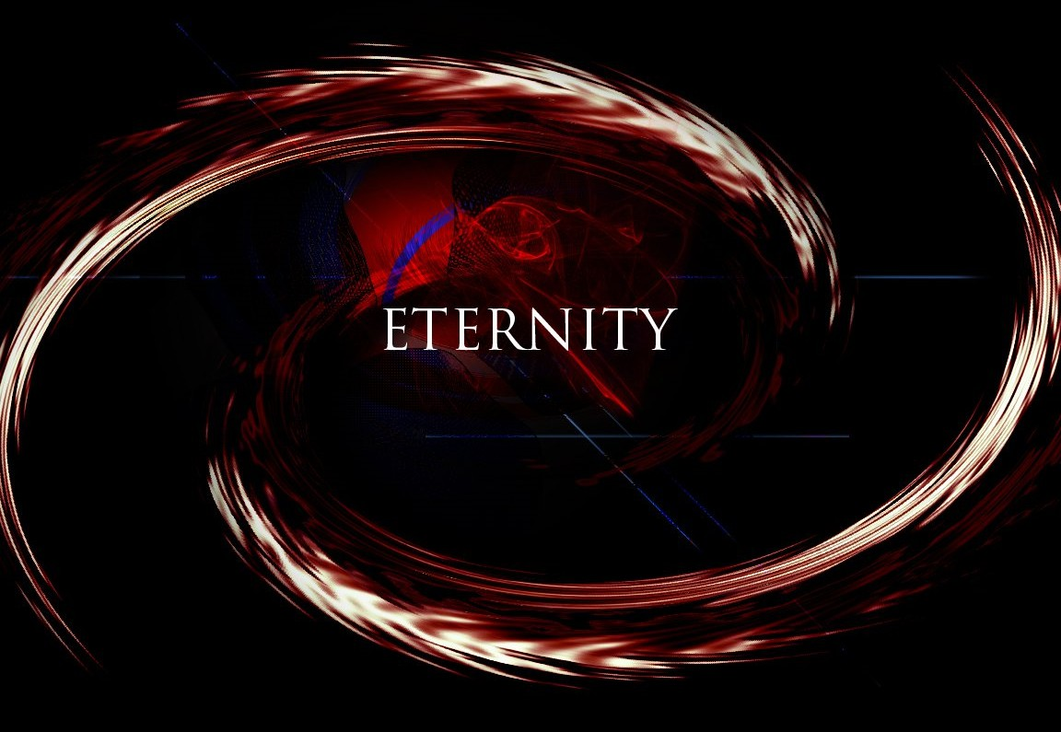

Energy began when a movement happened.

Movement is caused by resistance and to understand where the movement came from it is necessary to ascertain "What was resisted?"

ETERNITY was resisted.

ETERNITY twisted and returned, and this is as a 'Mobius' twisting until the resistance is clarified.

“What is understood, stops repeating itself.” - Krishnamurthi

All as one we had a thought, and the thinking of that thought is as a Mobius Strip eternally recurring.

"The whole is more than the sum of parts." - Aristotle.

The sum of thinking is the mind of resistance and because it is eternally recurring it is everywhere at once.

“I received a telephone call one day at the graduate college at Princeton from Professor Wheeler, in which he said, “Feynman, I know why all electrons have the same charge and the same mass” “Why?” “Because they are all the same electron!” ~ Richard Feynman.

We want our cake and eat it too.