OCEAN OF THOUGHT

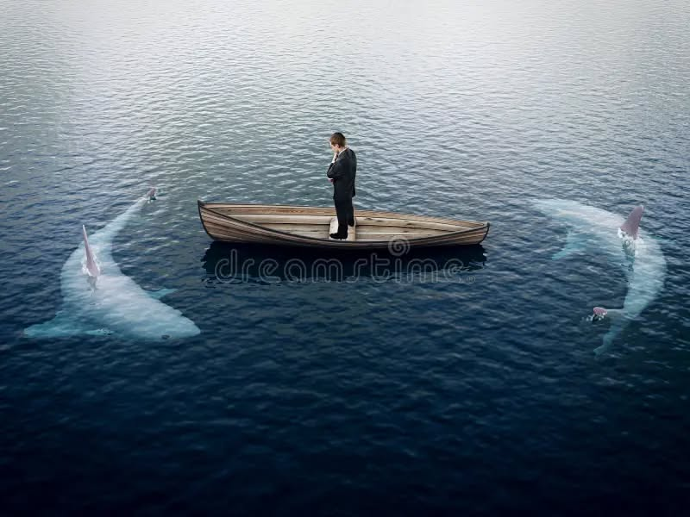

Everything is pumping out of Eternity at the same time but we fool ourselves not to know this.

One is all/Eternity has no other and the thought that twists Eternity is the exercise of thinking.

Thinking is the movement of thought – bursts of energy called quanta.

The universe is the result of thought thinking. Or the universe is the secondary result of **Quantum** repetition.

**'Not to know it is blindness that works evil."** - Tao Te Ching.

One movement twisting in/out of heaven is all but we choose to seek heaven elsewhere and the sum of our choosing (all as one) has become a force of such denial that individually we no longer perceive the heavenly gift in front of us.

The universe is eternally recurring - heaven at our fingertips but we are tricked by the mass of thinking, as one consciousness overall.

**“The whole is more than the sum of its parts.”** – Aristotle.

The primordial resistance is everywhere at once as the cause of the twist.

It is the Quantum thought.

And so, all as one we are a mass of resistance led by one pre-existent thought - small enough to fit everywhere at once - enacting the will of all as one - with impunity.

There is no choice in this for the one on-high has no life but by consensus – a soulless thing.

**“The whole is more than the sum of its parts.’** – Aristotle.

Aristotle captured the ignominious soul of humanity and held it to view, none, to my knowledge, have yet seen this view and that is why Aristotle’s insight has remained a curiosity.

Now, we may finally see humanity for what it is.

**“I will ascend to the heavens; I will raise my throne above the stars of God; I will sit enthroned on the mount of assembly, on the utmost heights of Mount Zaphon. I will ascend above the tops of the clouds; I will make myself like the Most High.”** – Isaah 14:13-14.

For humanity to come out from this trap of energy, it must establish thought as ILLUSION and thinking as trickery.

Then, we may focus on the trap we have set to protect the thinking we formulate.

Synopsis:

All as one, we are everywhere at once protecting life for its own sake against naysayers like Lao Tzu, Isaac Newton, Max Planck, Nikola Tesla and all who have shone precious light only to be washed back and assimilated by the massive force that is the ocean of thought.

**“Let us guide humanity not to ascend above the clouds, but to descend into the present, where the Way flows unseen.”**