**“One infinite pure and holy—beyond thought beyond qualities I bow down to thee”** - Swami Vivekananda

ONE ELECTRON

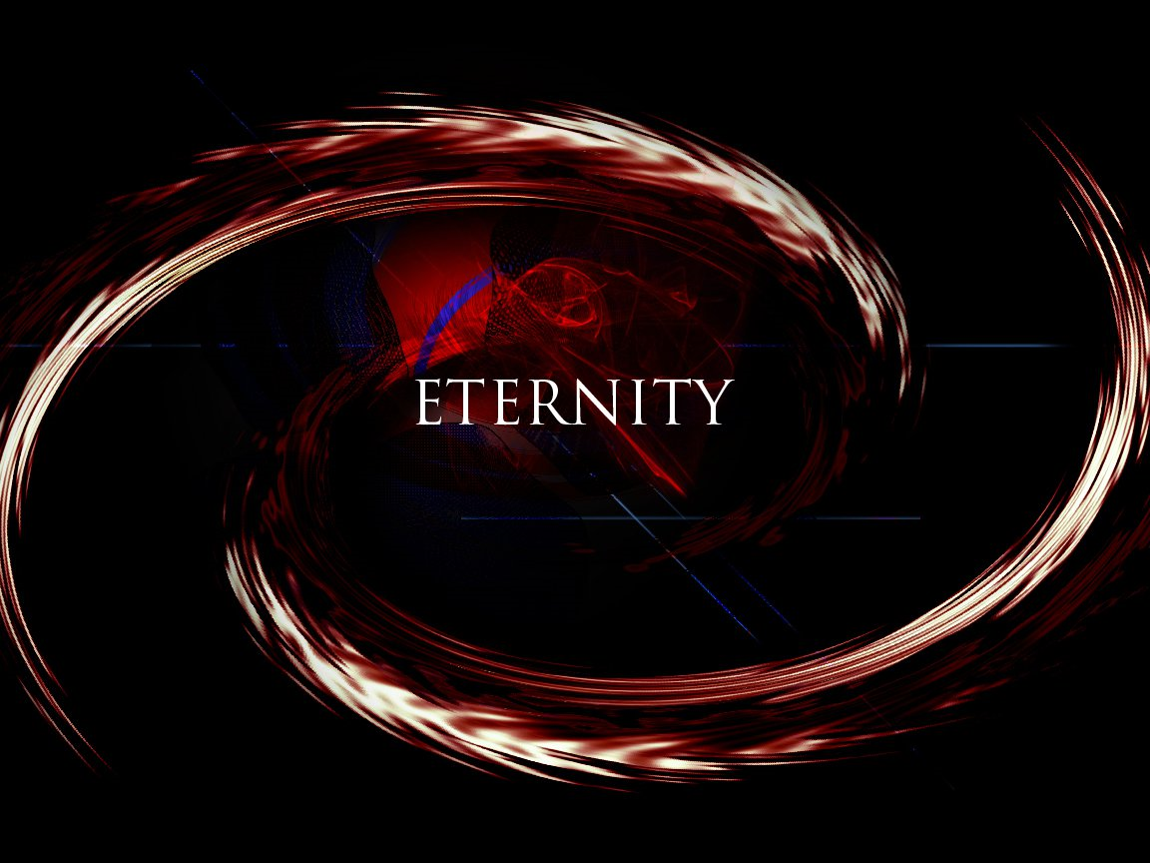

As we pulse from Eternity we grow the heart of the universe.

The pulse remains sacrosanct for Eternity does not change.

The frequency of thought is unlimited.

Thinking is the movement of thought.

As thought grows, the universe expands.

Thought is the electron; everywhere at once as the heartbeat of all.

This is the One Electron as proposed by John Wheeler in a conversation with Richard Feynman in 1940.

***“I received a telephone call one day at the graduate college at Princeton from Professor Wheeler, in which he said, “Feynman, I know why all electrons have the same charge and the same mass” “Why?” “Because they are all the same electron!”*** ~ Richard Feynman.

The sum of electrons is an ocean of thought.

**"The whole is more than the sum of its parts."** Aristotle.

The mass of who we think we are, is inseparable in its ascension - it is how we exercise our will with impunity.

ONE IS ALL, meanwhile we resist what is eternally so.

**"There is a central pulse to the universe that beats a rhythm into our being whether we are listening or not. It contains everything that we are and knows all our heartbeats as one. It is who we are when we stop pretending to be something else."** - Eternal Recurrence ...A Step out of Time.