ONE HAND CLAPPING

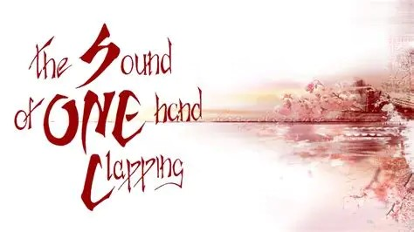

The cause of thinking plays each eternal beat according to the collective will of the people – one and the same - a hand clapping itself.

The thought structure is one energy packet repeating from Eternity to reproduce itself without going anywhere.

**The eternal generator is a wheel spinning output just as a hairdryer.**

**"I would not give my rotating field discovery for a thousand inventions, however valuable... A thousand years hence, the telephone and the motion picture camera may be obsolete, but the principle of the rotating magnetic field will remain a vital, living thing for all time to come."** ~ NIKOLA TESLA. November, 1928.

Thought is all as one moving away from itself.

There is no other than an illusion fermenting.

The mind of thought is the mind of the human body.

**“There is but one process of thinking for there is but One Mind.**

**There are not two Minds nor two methods of thinking; nor are there two sets of laws governing thinking.**

**Nor are there two separate substances, nor two separate things nor two separate beings in the universe.**

**All thinking is universal thinking.**

**All thinking things are thinking in unison.**

**All are creating that which they are thinking.**

**All thinking things are self creating.**

**All thinking things are creating all things.**

**Man is his own creator.**

**Man is the creator of all that is.”**  ~ Walter Russell.

All, as one, we watch everything with undivided attention, for even though thinking is all-inclusive there are always those that ‘think out of the box’ - those who might topple the illusion.

So far, this has not happened for when the greats of science and philosophy come forward, they are cleverly controlled by the sum of who we think we are.

**“The whole is more than the sum of its parts.”** – Aristotle.

All as one we reign supreme.

Until it is recognized that each one is part and parcel of the whole it will not be possible to re-connect with the eternal source.

**“Eternity is the source of energy.”** – Nikola Tesla.

The eternally recurring universe has the sound of one hand clapping.