PHOENIX RISING

**“It is important to realize that in physics today, we have no knowledge of what energy is.”** - Richard Feynman.

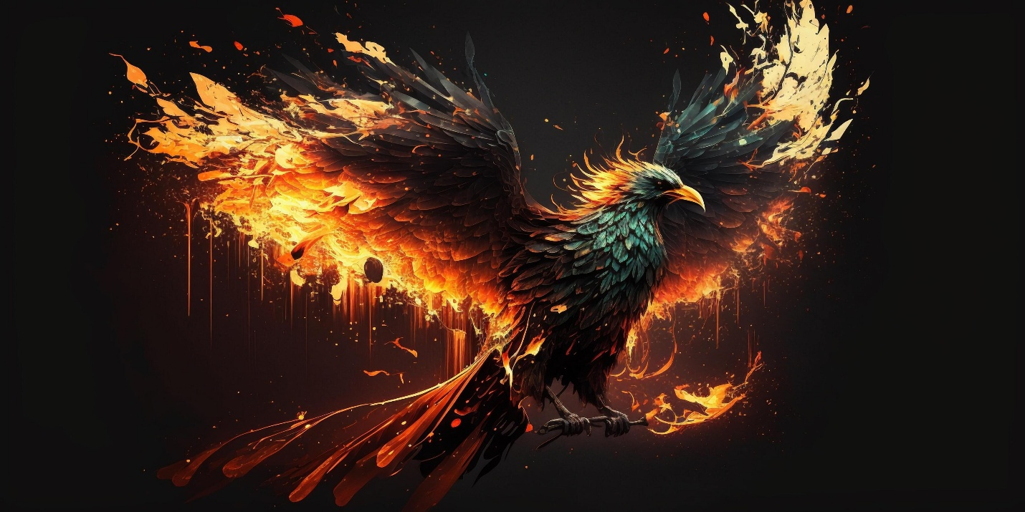

I can tell you for sure that we are all going to die yet few want to know how we got here or what happens when we die.

Also, I can tell you for sure that the universe is energy.

Energy is movement, consequently the universe is an ILLUSION.

The universe is an energetic illusion we feed with our lives.

The fire continues - always new fuel being born,

We are bursts of energy drawn from ETERNITY.

Frequency is unlimited, on demand and free.

**“Draw from it as you will, it never runs dry.” –** Tao Te Ching.

We feed the fire with our lives.

The fire is the mind of its changing parts.

**"The whole is more than the sum of its parts."** - Aristotle.

We die to keep the fire alive – to keep this thing that is the sum of us ALIVE, and we have no answer to why we do this.

**“You will burn, and you will burn out; you will be healed and come back again.”** – Fyodor Dostoevsky