**ISAAC NEWTON** (F=ma) described the disintegration of mass/time to ETERNITY.

**.**

A RECKONING AT HAND

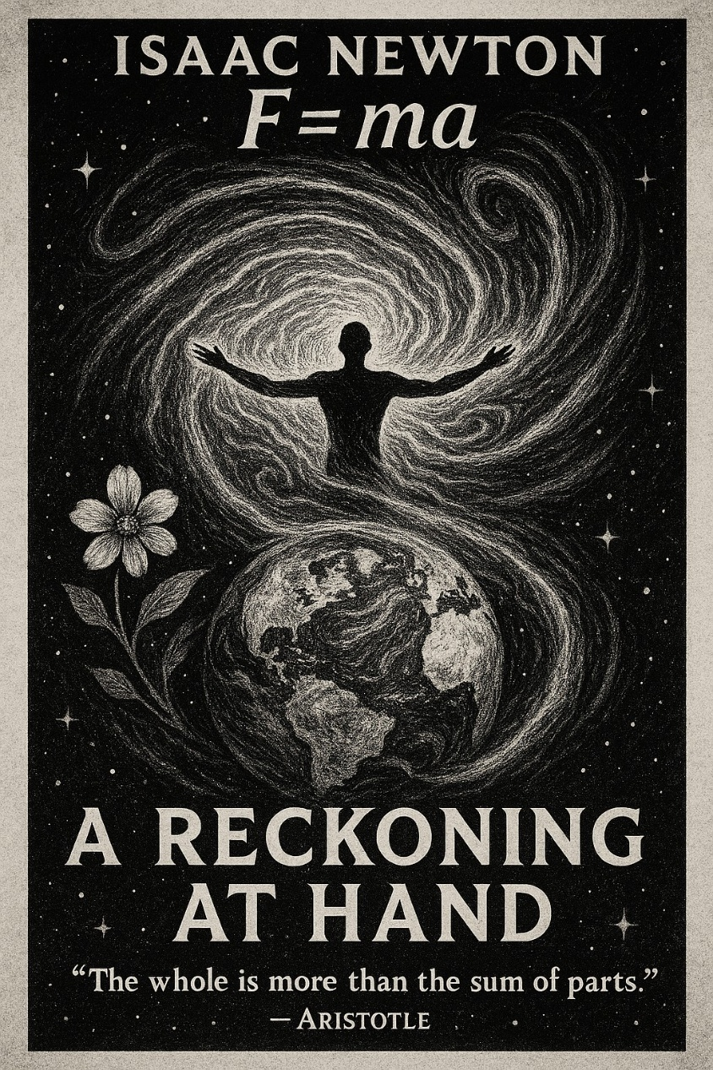

**ALL IS ONE.**

We denied who we are and created the universe as our proving ground.

ALL as one, we turned to energy - a twisted movement – a thought.

The fires of thinking keep thought alive, and because we are in this together there is a structure to the exodus.

The energy packet repeats and voila the universe appears as a movie playing – one frame at a time.

One eternal movement pumping out packets of energy until the view is regained.

The universe is accumulation of the same eternally recurring packet of energy – a point of view making its point.

**"The whole is more than the sum of its parts."** - Aristotle.

The parts compete to become what they are programmed to become.

A flower knows not but to become a flower.

**“Man is the only creature who refuses to be what he is.”** - Albert Camus.

Each part is divine, and the sum of parts is the collective whole.

ALL as one, we are an ocean of thought, and waves are assimilated.

But, the **Tao, Isaac Newton, Max Planck, Nikola Tesla**, and all the sparks of truth will not stay quiet as the ocean of thought gathers more and more into its web of deceit.

There is a reckoning at hand.