THE SURVIVAL OF THOUGHT

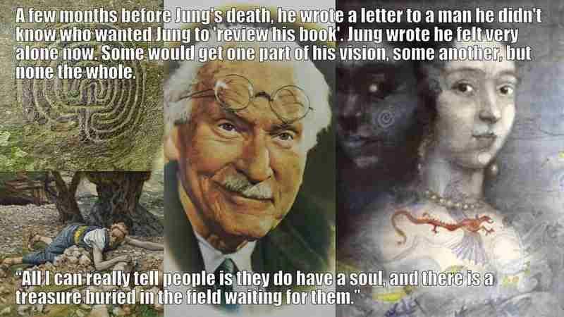

**Man must recognize his complicity in the act of evil.”** - Carl Jung to his Soul, The Red Book, LN 291.

All as one we had a thought.

Thought is a movement away from Eternity.

The sum of movements is the thinking of thought.

**"The whole is more than the sum of its parts."** - Aristotle.

The collective principle is everywhere at once.

It is all as one - **antithesis.**

~

Thought, because it is a movement is an ILLUSION, and for the players to admit this fact of energy is to cast doubt on thought.

We agree we are energy, yet we won't accept that movement is illusion - such is the power of our ability to fool ourselves.

This is the level of ignorance we engage we engage as the sum of who we are - this monstrous ignorance that is everywhere at once like a wraith doing the work of keeping us alive at any cost.

There is no other this monster sends us to war to protect the rest of us; it makes our decisions in our stead and has our permission to wreak havoc.

Meanwhile, we sit back and blame others. never caring to know that we are cause and effect: one umbrella of thought, acting for the survival of all as one.

**“...frightening thought that man also has a shadow side to him, consisting not just of little weaknesses- and foibles, but of a positively demonic dynamism. The individual seldom knows anything of this; to him, as an individual,**

**it is incredible that he should ever in any circumstances go beyond himself. But let these harmless creatures form a mass, and there emerges a raging monster; and each individual is only one tiny cell in the monster’s body, so that for better or worse he must accompany it on its bloody rampages and even assist it to the utmost. Having a dark suspicion of these grim possibilities, man turns a blind eye to the shadow-side of human nature. Blindly he strives against the salutary dogma of original sin, which is yet so prodigiously true. Yes, he even hesitates to admit the conflict of which he is so painfully aware.”**

~ Carl Jung, “On the Psychology of the Unconscious”.