**THE WATCHER**

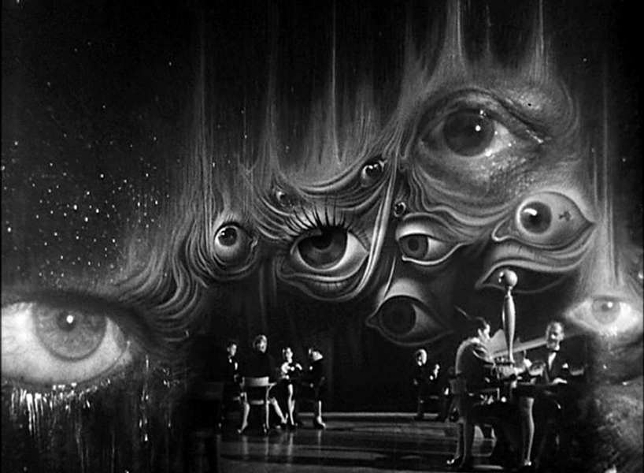

**“It is important to realize that in physics today, we have no knowledge of what energy is.”** - Richard Feynman.

We spin off an eternal coil like a hairdryer producing output.

The sum of outputs is the cause of the coil.

**“The whole is more than the sum of its parts,”** - Aristotle.

The silent cause is everywhere at once directing its effects to maintain its kingdom on earth.

**“According to a theory proposed by theoretical physicist John Wheeler, who outlined his thoughts in a conversation with fellow physicist Richard Feynman there is only one electron – it just looks like there are a lot more because it is moving forward and backward in time.”**

The right hand doesn’t know what its left hand is doing, and so we burrow down for fear of the unknown - subliminally aware we are being watched as we go.

**“John Wheeler’s “one-electron universe” is a bold and imaginative hypothesis suggesting that every electron and positron in the universe is actually the same particle—zigzagging through spacetime, moving both forward and backward in time.”**

Our collective thought's do not want to reveal the ‘watcher’. We do not want to admit that we are one and the same - that we are both the watcher and the watched.

The watcher is not hidden by force, but by consensus. We agree not to see. We choose not to unify. That’s the deeper tragedy.

**'Thought creates our world and then says 'I didn't do it"** - David Bohm.