THE WORLDWIDE WEB

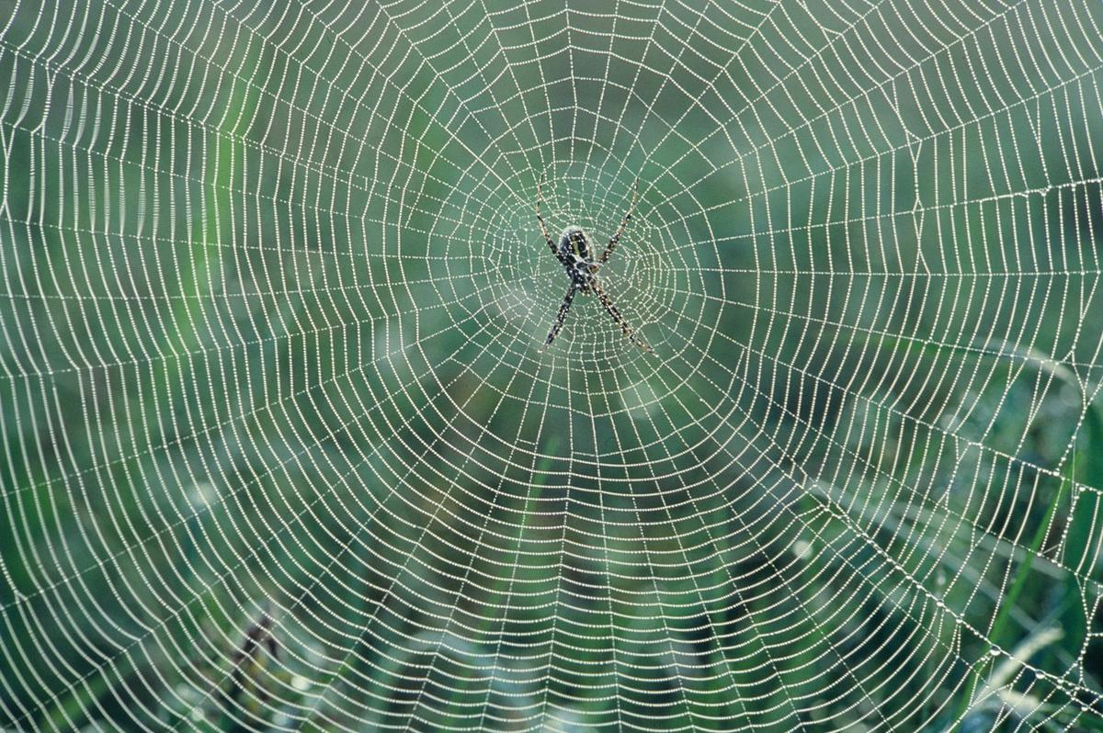

**Humankind has not woven the web of life. We are but one thread within it. Whatever we do to the web, we do to ourselves. All things are bound together. All things connect.'** - Chief Seattle.

Humanity is a consensus of opinion that is everywhere at once.

**"The whole is more than the sum of its parts."** - Aristotle.

Aristotle insight has few takers. This is because the sum of parts is as the ocean to a wave.

The same movement vibrates in/out of Eternity until the parts come to their senses and sees an eternal mechanism pumping output for the work to be done.

The work is to rationalize the resistance that caused the movement in the first instance.

We build resistance to solve resistance but as a spider builds a web, we trap ourselves in the web.

**"…and they may come to their senses and escape from the snare of the devil, after being captured by him to do his will."** - 2 Timothy 2:26.

Humanity is cause and effect.

**“Oh, East is East, and West is West, and never the twain shall meet.”** - Rupyard Kipling.