**"The first principle is that you must not fool yourself and you are the easiest person to fool."** - Richard Feynman (1918-1988), Nobel Prize winner.

TWISTED ANGEL’S

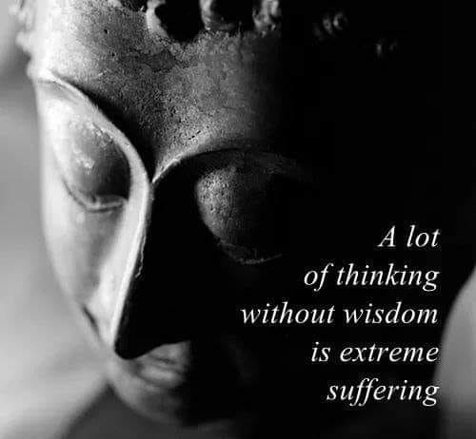

We twisted out of Eternity - re-aligning and repeating.

The twist is thought.

ALL as one we had a thought – thought has the same energy no matter how often it twists and turns. (Planck’s quantum)

Thinking is thought exercising its mind; everywhere at once.

The body of thought disappears with each eternal twist.

Eternity is as close as our denial of its presence.

All as one, we are a collective thought – an ocean of waves.

**“The whole is more than the sum of its parts.’** – Aristotle.

The collective makes sure its parts remain in place.

This is evident by our inability to rationalize fundamentals in the face of great achievements...

~ The universe is energy, energy is movement, movement is illusion. ~

The universe is illusion, but we think we are real.

The Collective lives in shadow – it is everywhere at once influencing its parts to cooperate.

If you can observe your reaction to my words, you may gain an insight...

You are being watched by the collective as it makes a fool of you in front of me.

I observe the Collective in action.

“We give our power to less - a lessening to invest.”

We invest in energy without knowing what energy is.

**“It is important to realize that in physics today, we have no knowledge of what energy is.”** ~ Richard Feynman.

Anonymity is our fool’s cap.

We will even go to war for the cause.

We are the parts that ambulate the world allowing us to participate in everything at once - incognito!

We are part and parcel - inseparable!

Everywhere at once, clever, clever, as we fool ourselves to keep the fire alive.

We seek to glorify life for its own sake, and we achieve this by disguising ourselves in energy.

Clever we be, and good we are like angel’s most of the time.

“The body of thought disappears with each eternal twist.

Eternity is as close as our denial of its presence.”