UNIVERSAL FAIRYTALE

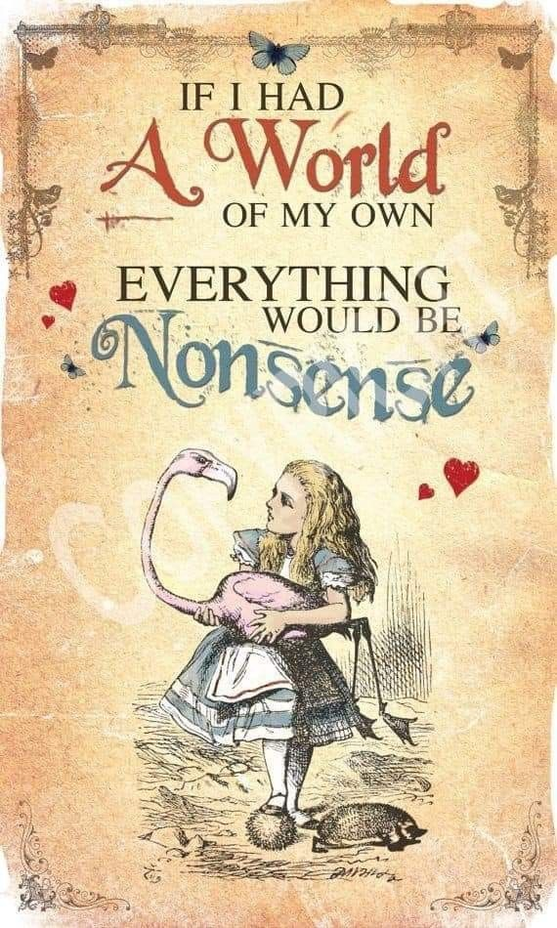

The universe is energy - energy is movement - movement is illusion.

We do not accept the universe as an illusion though it is irrefutable.

**“Eternity is the source of energy.”** – Nikola Tesla.

Nikola Tesla was aware, yet, in spite of his achievements we still don't accept Eternity as the source of energy.

We demand proof.

Eternity has no counter-balance - no other!

Consequently, it has no reference by which to be proven.

The movement called energy began when Eternity resisted Eternity causing a movement best described as a twist - a movement turning back on itself like a Mobius strip going nowhere.

Eternity cannot divide yet it responded to RESISTANCE (thought) making a hiccup in time. Otherwise, we would not be here insisting we are real - whatever that means?

All as one, we created an illusion to believe in.

The illusion can be proven; Eternity cannot be proven.

And so, off we go on our high horses creating reasons to perpetuate illusion, building contracts against the truth.

Eternity is unconditional Love, yet contracts on love bind society and procreation fuels the fire.

Proof forges ahead building new means to validate nonsense.

Proof is a false prophet.

**"Not to know it is blindness that works evil."** - Tao Te Ching.

Charles Lutwidge Dodgson was an accomplished 19th Century mathematician who saw through the illusion.

He wrote Alice in Wonderland under the pseudonym Lewis Carroll, as a way to explain why 'proof' is a fool's game.

The universe is a circle opening/closing.

**“It is important to realize that in physics today, we have no knowledge of what energy is.”** - Richard Feynman.