WE ARE THE ONE

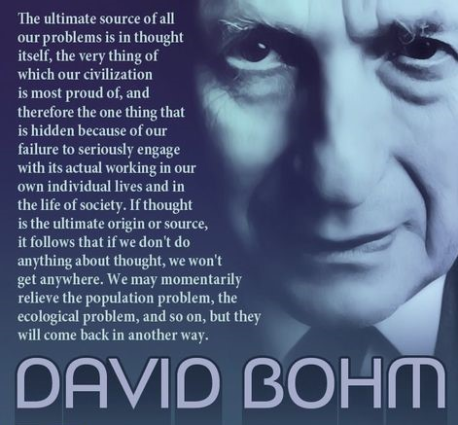

Despotic elements do not happen by chance - they are bursting sores resulting from the mass of thinking. (balance restored)

But because we don't know what thinking is, we are in thrall to it.

Thinking is the repetition of a single thought that appeared from nothing.

Thought is the first, and only movement.

Each repeat the same because it is ETERNAL.

Nothing/without reference is everything together without difference. This is unconditional love/Eternity.

Thought is resistance - All as one, we twisted without disconnecting - establishing a movement, an illusion.

The eternal pulse is the motherlode that cannot refuse its own - one and the same - inseparable!

The twist of movement is the quantum.

The universe is the secondary result of quantum repetition.

The quantum is Planck's constant (6.62607004 x 10⁻³⁴ m² kg seconds.)

The eternal pulse is a circle in a state of collapse. - no reference to measure - Eternity is nothing!

All as one we direct the universe by proof, this is how we fool ourselves into thinking we are real.

Meanwhile, the sum of 'who we think we are' knows better - we know better, but care not to divulge as long as our plates are full.

"Only he can be just who is able to put himself in the position of others." – Gurdieff.

Gurdieff's "he" is All as one. - everywhere at once.

'"The whole is more than the sum of its parts." - Aristotle.

'He' is the one to establish as our own.

“I will ascend to the heavens; I will raise my throne above the stars of God; I will sit enthroned on the mount of assembly, on the utmost heights of Mount Zaphon. I will ascend above the tops of the clouds; I will make myself like the Most High.” – Isaah 14:13-14.