Will O The Wisp

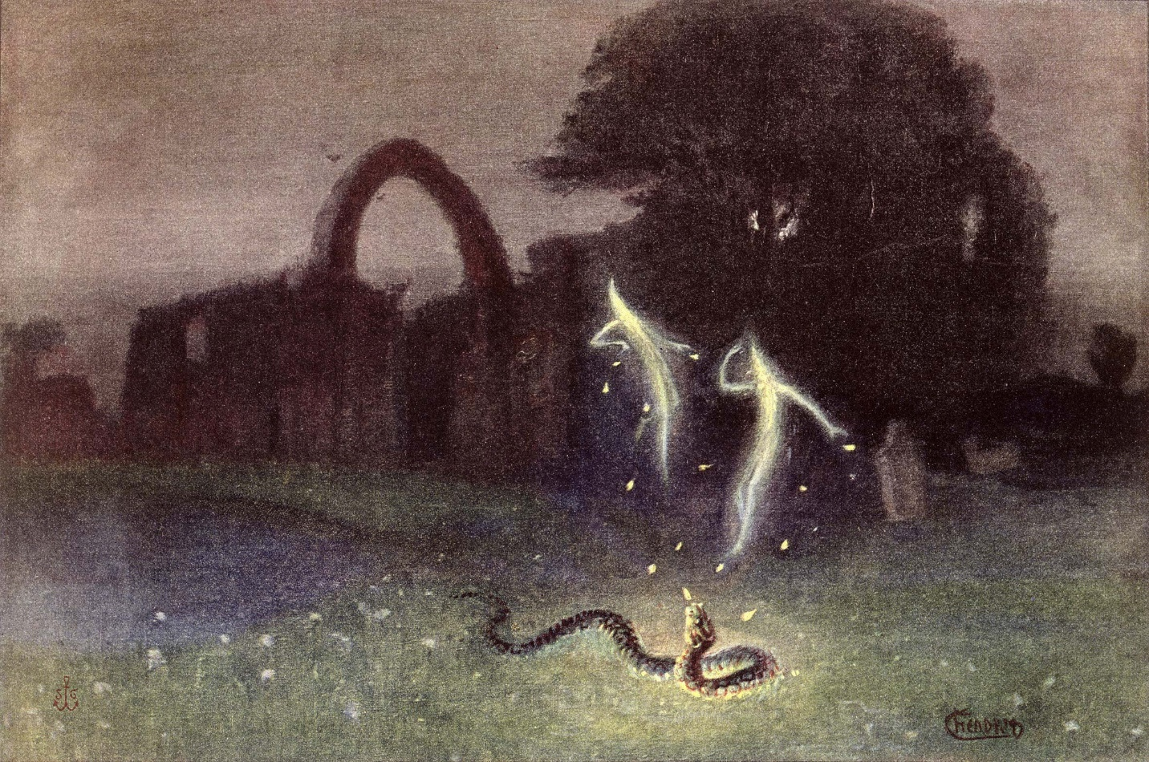

We come from Eternity in discreet bursts of energy that accumulate to a pyramid-like structure whose pinnacle is the ever-changing sum of its parts.

"The whole is more than the sum of its parts." -- Aristotle.

This is the ship of state by which we travel in energy.

The ship’s master is the constantly changing sum of who we think we are.

Quantum mechanics has arrived at the pinnacle of thinking: a particle that won’t sit still.

This particle is the sum of who we think we are in a constant state of transition.

~

Measure, define and control

Make it belong, make it whole

Nail it down so we can own

Use it to advance the goal.

What we can’t measure we can’t control

Such a dilemma – must control!

The cutting edge of science has found

A particle that wants to dance alone.

How do we explain this wisping whim

Moving around, won’t sit still;

A new frontier to nurture fear

Or a virgin birth to become more clear?

Linear complexity, an idiot’s delight

This dancing thing just wants to play

Pied Piper piping away

Must turn back or crash and pay!

What is this thing our science can’t hold

This messenger entreating us to unfold

A portal, a doorway to a brand new day

A higher rung to see the Way.