A MONSTROUS PRESENCE

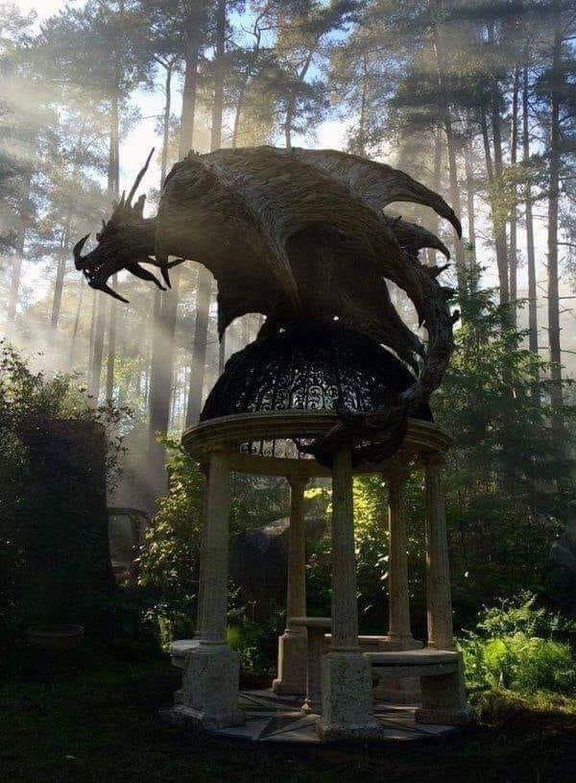

The masters of time are as waves to the ocean of thought.

Thought is a twisted movement; an eternal hiccup that repeats until reconciled.

All as one, we resisted ONE is all.

We established time without disconnecting from Eternity.

We build it bit by bit, simply by thinking -

Thinking is the movement of thought - thought becomes this collective one that's everywhere at once.

The mind of man is a gathering of bits.

**“I received a telephone call one day at the graduate college at Princeton from Professor Wheeler, in which he said, “Feynman, I know why all electrons have the same charge and the same mass” “Why?” “Because they are all the same electron!”.** ~ Richard Feynman.

We are the minions of thought - a changing mind that is everywhere at once.

Thought is entirely personal and central to thinking and when there is challenge to the status quo thought sends its minions.

The ocean of thought is the mind of man everywhere at once.

The mind of man attempts to steal heaven at such a cost.

The power of the oceanic overwhelms its waves as it assimilates information to serve its cause.

The ocean carries the will of the people for it is the sum of who we think we are.

A TEST:

If the leaders of time can't explain the difference between Newton's F=ma and Einstein's E=mc², they have been assimilated.

The ocean is the sum of all as one.

**"The whole is more than the sum of its parts."** - Aristotle.

Before we may begin to reconcile, we must take responsibility for this monstrous presence we have created.

**“He who fights with monsters should look to it that he himself does not become a monster.”** - Friedrich Nietzsche.