BEHIND THE SCENES

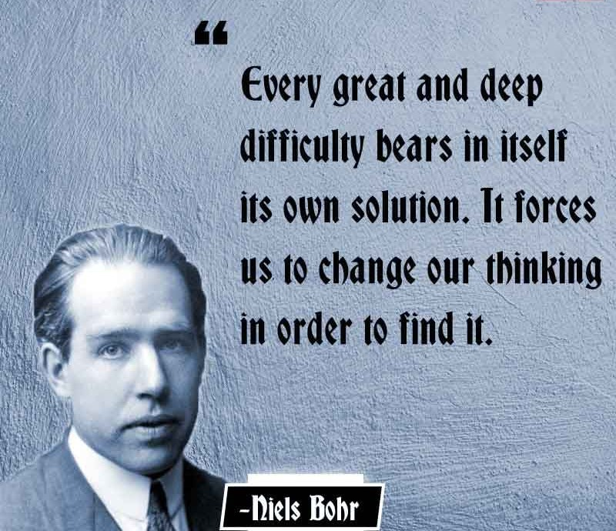

**“Ultimately, the entire universe... has to be understood as a single undivided whole.”** — David Bohm

Humanity believes it holds the higher ground—that it must be catered to, as if it has a right to be proven. As if it is the prize to be won.

I do not need your prize; I am my own. And my own already includes you.

You mass against me because I am one and you are many as one. You do not know how the energy dynamic works or its true purpose.I will tell you that it is love, but you refuse to learn the construct of love in the world. You refuse to know that energy is illusion—and because it is so, all things are possible.

**“Wholeness is what is real, and fragmentation is the response of this whole to man’s action, guided by illusory perception.”** — David Bohm.

Isaac Newton expressed a single movement: **F = ma**. All else is the result of its repetition—a generator creating the means to solve itself.

The movement is eternally recurring—each repeat the beginning of time. The resistance that caused the movement is everywhere at once.

The primal resistance is thought, and we are the movement of thought. Thinking is the movement of thought—one and the same—inseparable.

The sum of thinking is the mass of thought existing as a singularity; everywhere at once.

**“The collective unconscious contains the whole spiritual heritage of mankind’s evolution born anew in the brain structure of every individual.”** — Carl Jung

To dissolve the mass, one must gain the wherewithal to recognize thought as the center of being and know that we are all part and parcel.

All as one, we mass to a fortress that defends our points of view. We destroy those that challenge the collective paradigm.

Massing as one is a natural defense reaction bred from fear of the unknown. The sum/mass of thinking unifies to a protective force with the ability to be everywhere at once.

**“The whole is more than the sum of parts.”** — Aristotle

This is the way of things.

Newton, Planck, and Tesla demonstrated the construct of love in the world. And to return to love, we require transportation—not of the body, but of the soul.

**“The conception of substance can only be a conception of one substance.”** — Baruch Spinoza

It's time to introduce ourselves to the psycho-emotional universe and learn what's going on behind the scenes of thinking.

**“According to a theory proposed by theoretical physicist John Wheeler, who outlined his thoughts in a conversation with fellow physicist Richard Feynman: There is only one electron—it just looks like there are a lot more because it is moving forward and backward in time.”**

Multiplicity is illusion. Unity is reality.

This is the way of things.

And now, it is time to return.

*Inspired by the works of David Bohm, Carl Jung, Baruch Spinoza, Isaac Newton, and John Wheeler.*